GRASSROOT, HOME-BASED REHABILITATION SERVICES FOR CHILDREN WITH NEUROLOGICAL DISORDERS IN UGANDA:
A PILOT STUDY

Part II: Appendices

Appendix A
Overview of the questions and collected answers before first training

The overview of answers of children without a disability and caregivers of children without a disability can be given upon request.

Overall questions:
- How is quality of life perceived in Uganda among caregivers, children and fieldworkers?
- According to them, what could improve quality of life?
- When thinking of how this could be improved and the STEP training phase, what should be included in the training?
- What key message do you have for the participants of the STEP training?

Quality of life according to caregivers of a child with a disability
Body functions & structures  - Good start, no illness  - Parents feeling well, no illness  - Growing well, improving function  - Medication to stop epilepsy and constipation  - Not being ignorant about the child’s condition  - Understand the child’s condition | Activities  - Being more independent when older through study and improving function  - Improved mobility  - Seeing child in school, studying well  - Child being able to take care of herself  - Child can get exercises  - Some supports in their hands and improve hand function  - Learn vocational activities e.g. tailoring  - Can live independently in the future  - Walking well, being independent  - Child eats and sleeps well, not refusing food  - In the future she would be able to help herself |  | Participation  - Child is participating very well at school and home
Personal factors  - Child feeling very well  - The child is at home  - Feeling happy with other children, even with the children in the community  - Child having self-confidence  - Child feeling happy with himself  - Caregiver feeling happy with the child  - Feeling the pain of the child and child feeling her pain  - When the child is happy, I am happy  - Parent not losing hope if the child can be trained anything to do |  | Environmental factors  - Whole family is feeling very well  - Father not neglecting the child/ not leaving  - Good income incl. money for school fees in time, to fully provide for the child  - Child getting anything wholeheartedly e.g. child doesn’t have to say “my father neglected me”  - Child feels parental love  - Having a family of your own  - The family should be stable: participating equally and fully in taking care of CWD  - Able to have enough money to buy food and taking care of children at home  - No stigma from the community, even when the child is married or gets married  - Having good and appropriate education  - Able to get rehab activities e.g. mobility aids and other assistive devices  - Being able to get any job with liable income  - Being able to have a parent group with common interest and goals  - Good professionals to work with the child  - Giving the child food and drinks in time, balance good food  - Parents involved in taking care of the child  - Help by organizations e.g. take her in school, learn for example handwork  - Having extra time for the child
Remarks
- “When the father heard the child was disabled, he said that in our clan/family we don’t produce CP children. So, he neglected her and child now completely.”
- “She took too much time of me and the other children, so I could not have more children”
- Mainstream schools are perceived as not having enough facilities, knowledge and skills for a child with a disability.
- “Because my child has CP, it doesn’t mean my child is unable”
- None of the caregivers had CBR-/field workers coming to their house. No home-based services.
- Caregivers want someone responsible for services e.g. assistive devices: identify and follow thru.
- Responded happily to idea of ‘expert caregivers’ in training.
- Need to create parent support groups before start of STEP training.
- Wish: “If she wants to go somewhere, it is her wish to always go with the child. She holds the child everywhere. That is okay for church but not for town, because she has to hold the child everywhere.
- Hopes: “that at one time he would be able to sit, stretching the hands. If the child can sit, it can help her because it takes a lot of time to carry him and she gets tires. When sitting he maybe could play with whoever is willing to play from the family around him.”
- Would like to be in contact with other caregivers of a disabled child to share information and knowledge and learn from each other. Especially if they know something you don’t know.
- “She talks freely to others about her child as a testimony, to inspire others”
Advised training content/messages
- Ask the mother how the child is progressing
- Being able to address challenges with school fees, walk like other children or have wheelchair to move from here to there.
- Remember how you left the child and if and how the child progressed.
- If you find the parents are not participating in taking care of the child, advice/comment on how they could help the child
- Not only talk to the caregivers but also to the child if he understands basic instructions.
- Knowledge is not for 1. If you identify mistakes of the parent, you should advice with knowledge and skills on how to do.
- Provide assistive devices or recommend where to get it (and not sell it).
- Advise or comment which school is best to bring the child to.
- Explain to caregivers how the child can be helped in some way, motivate the parent to give more care and love so child can have a good live and not only goes the ‘normal’ children.
- Advise the parent on what the parent should do so child can grow.
- The fieldworker should have a positive and optimistic attitude of the child: seeing potential. “Child could do something important tomorrow that people don’t read.”
- Being responsible to facilitate the child can develop well.
- Being able to transfer your knowledge and skills to the parent, so they can use it at home and child can live independently in the future.
- Train the fieldworker how to deal with neglect and stigma from family and how to handle the child so he can be like other children e.g. giving special shoes if needed, attending education so child can improve, grows well.
- Being able to be positive about education, even if child cannot write.
- Teach how the mother can train the child by herself at home e.g. writing, because of workload of teacher in classroom.
- Income generating projects to help child in the future.
- To see how the child is, the progress.
- Train the fieldworker how to do the exercises: stretching both hands and legs.
- How to handle, treat the children and talk to them nicely. Handling = she feels some people that work on children, stretch a lot and too hard and that hurts the child.
- “When the fieldworker visits the families of these children, they have to come with a positive attitude, not criticize, but positive attitude, even appreciating a little the child and family of the child. Even the language they use should be positive and good.”
- “Love these sick children, these parents and their work”

Quality of life according to CWD: What makes you happy/unhappy?
Body functions & structures  - Gaining more energy in arms and legs will help me do activities on my own | Activities  - Study books, being in school  - Stories I read in books  - Singing and listening to Afro beat  - Singing songs and repairing shoes  - I’m now able to walk better  - Being able to complete school so I can be independent in the future = own family, own clothes  - Playing with dolls and balls  - I like writing  - Learn to wash clothes better  - I like moving from one place to another, around school  - I like studying English  - I like washing cups and plates |  | Participation  - Going to school together  - Having friends in school  - Being home with brothers and sisters
Personal factors  - Seeing my grandmother who raised me and telling me stories  - Becoming a doctor in the future  - Become a lawyer, in Europe  - Becoming a nurse  - Reading books e.g. science & social studies  - I like sweets  - I don’t like it at school: when term is finished they rub on the chalkboard |  | Environmental factors  - Friends that abuse you  - Other children that beat you at school  - Siblings beating you at home  - Matron beating you when you don’t want help  - My parents don’t take care of me like I expect them (take me to school, give me a wheelchair to move around)  - My parents are able to bring me to school  - My brothers and sisters help me, love me and treat me equally as others at home  - Not being denied school  - Other children in school help me collectively e.g. going to toilet, washing clothes, in class
Remarks
- All children scored ‘5’ on the Likert scale = “very happy”
- Age varies from 6 to 20. Two teenagers, others around 7 years old.
Advised training content/messages
x

Quality of life according to fieldworkers
Body functions & structures | Activities |  | Participation  - Meaningful participation at all levels to create self-esteem:  - Active in community level  - Participation in home activities e.g. carrying plates
Personal factors  - I feel good, I feel loved and where I belong  - Some children give us joy which feels so happy |  | Environmental factors  - A person can get medication, shelter, clothes, food: this would improve QoL  - Joy from kids love me and feel I love them  - Being able to feed your children  - Help them perform well  - The community is happy, you are loved and be loved and encouraged  - Receiving health services from NGO  - Good comfort when orphaned  - Receiving community support  - Being helped according to your needs and problems: health, rehab, nutrition, establish economic substances  - Being brought up by your own parents, receiving parental love  - Being able to access rehab services e.g. physiotherapy and knowing where to get it from  - Inclusion in the society, community activities  - Community care, -involvement and positive attitude: people gathering food for the child, buying Christmas gifts, helping the mother out: being loved by the community adds to quality of life  - Teaching the community how to take care of the child when the mother is not there  - Not being stigmatized, people coming and caring for them  - Parents should encourage their child and keep doing so through difficult situations  - Encouraging parents first, maybe also to change their minds on taking better care of the child  - Acceptance, counselling and guidance of parents to include the child in the community so parents learn to accept the child  - Address economic empowerment of a family  - Access to (inclusive) education for children with severe CP  - Starting a special needs center in the community where you can get services e.g. therapy, school
Remarks
- “They [children with a disability] always miss out, they always retain to…they always move through the hands of the single mothers and don’t have that chance to be brought up by their own parents. They need parental love.”
- “In Africa, children with a disability are for women. The men don’t produce children with a disability. That one becomes for the woman, the good one comes for the men. So, you find the mothers are single handed caregivers for this. Father leaves with the good one and gets comfort somewhere. Mother is home, not working, cannot feed the child. Even if we sensitive the school, they still reject. Mother has to carry child to school. That is a big challenge for her. First the men ran away, child keep asking wanting someone to play with. Other children don’t want to play with the child. Some schools say “yes” first, when the mother comes with the child, they say “no”.”
Advised training content/messages
- Show some love first to parents and child when you see a child at home before you direct or advise them.
- Understanding the child’s needs, making sure others understand these too.
- Knowing about the problem.
- Make friendship with the parents first, then the child. Understand about the child and the needs. Then you can come in and know what child needs first. You cannot walk in first. You need to understand and give them advise accordingly.
- Put yourself in the mothers’ position. Show empathy to reach out to the family.
- First involve the parents, then the community after that. Parent knows who the child is and addresses the needs. After the parent accepted the child, family members get involved then the community comes in. You can’t accept the child if the parent doesn’t accept the child.
- Extending rehab services via outreach in the communities and health centers.
- Extend home based services to parents
- “As a fieldworker it’s not only about going to a home, talk and empathy “how is she” and “bye bye”, it’s beyond that. You must have knowledge and skills on how to help the child.”
- Group is unanimous that STEP training/ training focused in knowledge – attitude – skills can improve quality of life of children with a disability and caregivers: “knowledge is power, know how to work with the children. To learn to know what to do”.
- Nutrition and physiotherapy for children to prevent malnourishment
- Economic empowerment: training on income generating activities
- Training on CBR: how to conduct CBR including for children with hydrocephalus
- Using local available materials for assistive devices for most are too expensive for parents. You have to be honoust and straightforward with what you come to do. [Assistive devices are the most important part according to these fieldworkers] Sometimes you need two wheelchairs: one for school, one for home. The one in school is spoiled soon, the tires or by use of other children.
- Outreaches from home to facilitate access, direction and help: make referrals to medication services, places where they can interact with other parents with child with same type of disability, broader then a medical outreach
- Creating a relationship with the child [have difficulty answering what they could do more as a fieldworker, silence]
- Not only looking at money as everything but look at how we have to help this child. Set realistic goals and manage expectations. Don’t promise things you cannot give/buy and don’t buy incentives just like that.
- Sell them your love and friendship
- Train parents at home to deal with spastic children, stretching, massaging [medical model approach]
- Expectation management: “if parents here someone of children with a disability organization comes, they think everything is provided by them and parents forget about their responsibilities. They expect you to give everything, not all will understand if you tell them it’s their responsibility. We have to explain that to them. You are the one owning the child.”
- Parents have questions about taking care of the child.
- What to do if schools are far away. “Most parents let child stay behind because of the distance. Maybe the head director says we cannot manage your child and maybe someone else can look after him”.
- “We should sensitize the law enforcement group how to deal with issues of neglect.”

Appendix B
Overview of the overall training schedules and topics

Training 1
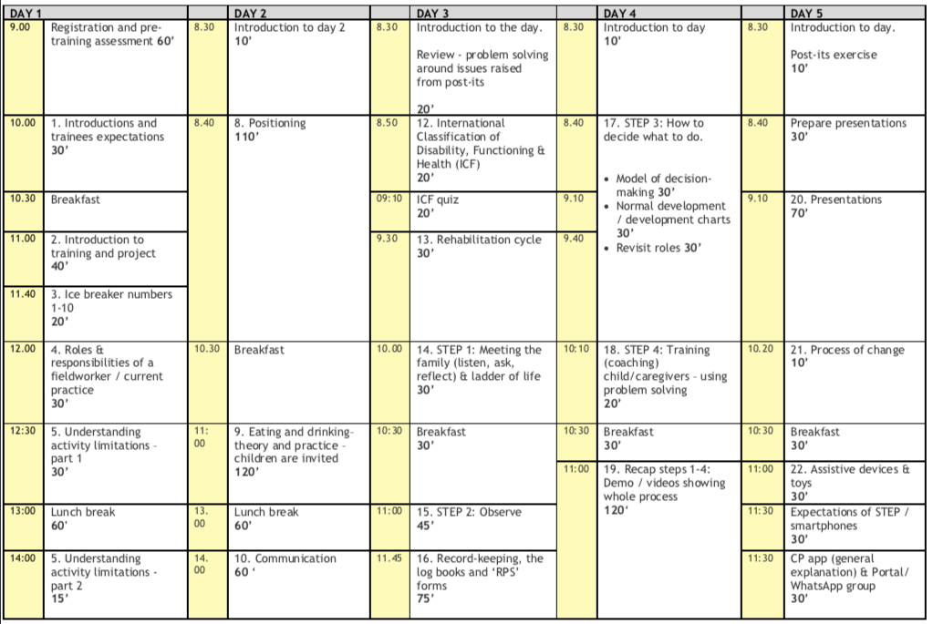
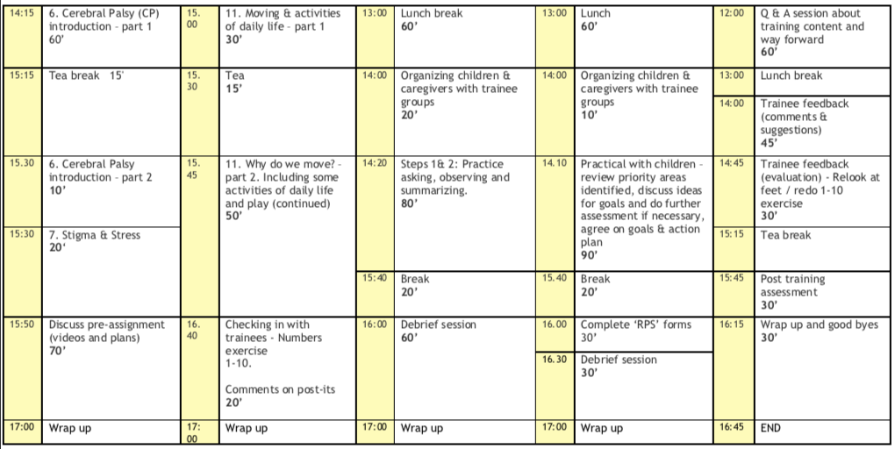

Training 2
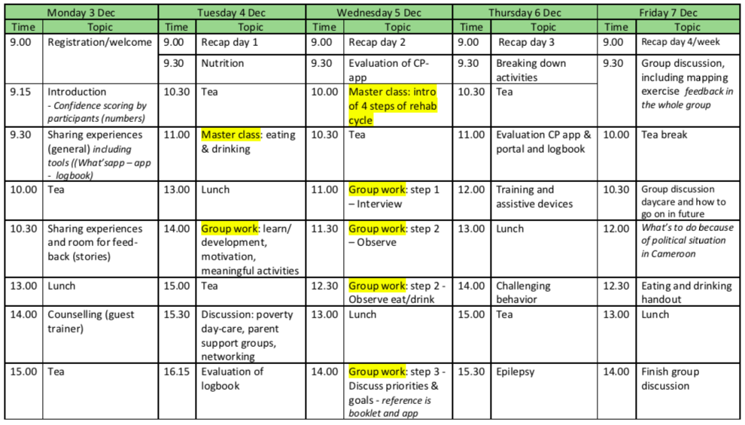
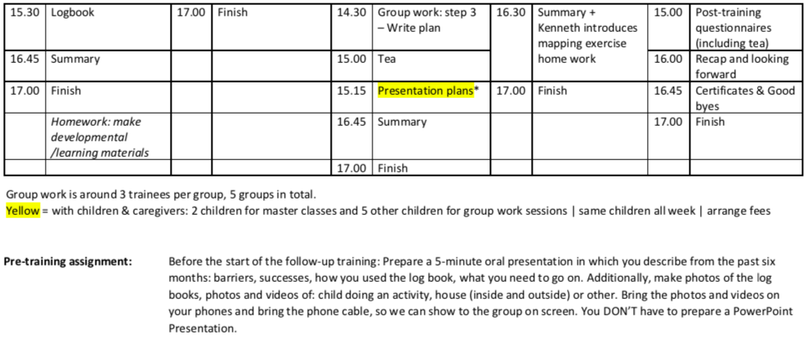

Training 3

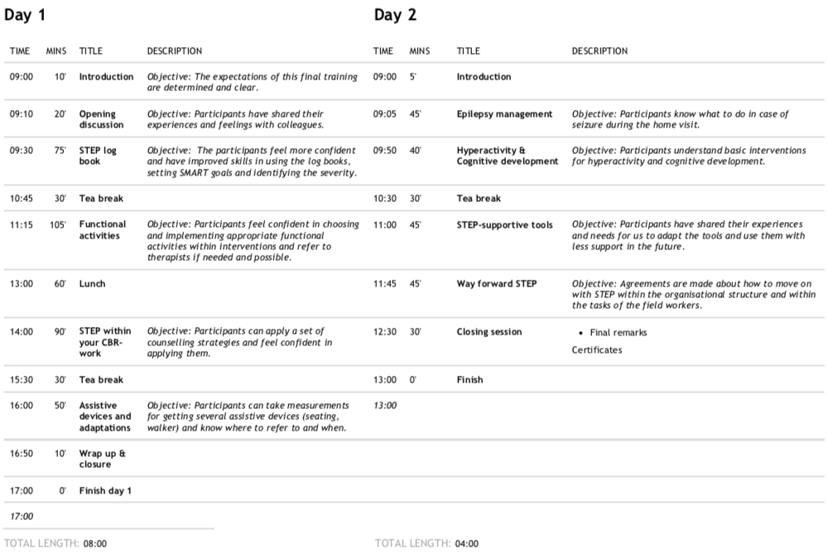
Appendix C
Logbook

A complete version of the logbook can be found on https://connect.lilianefonds.org
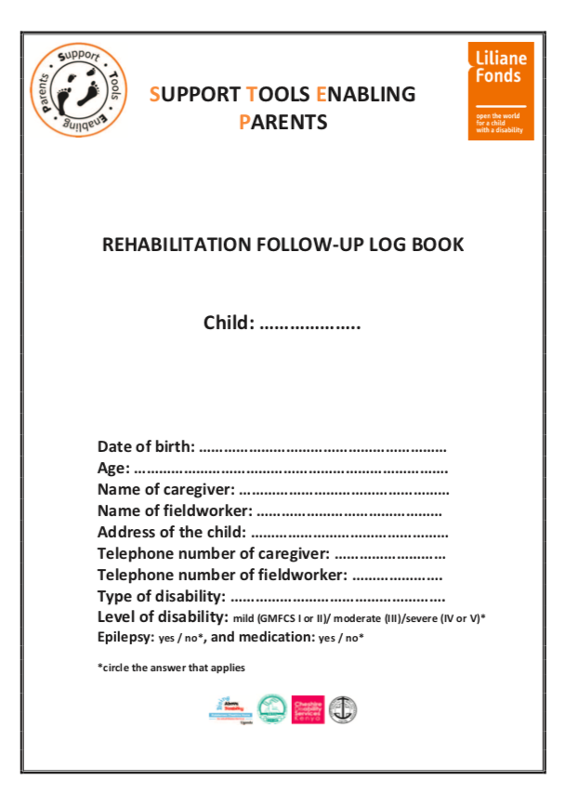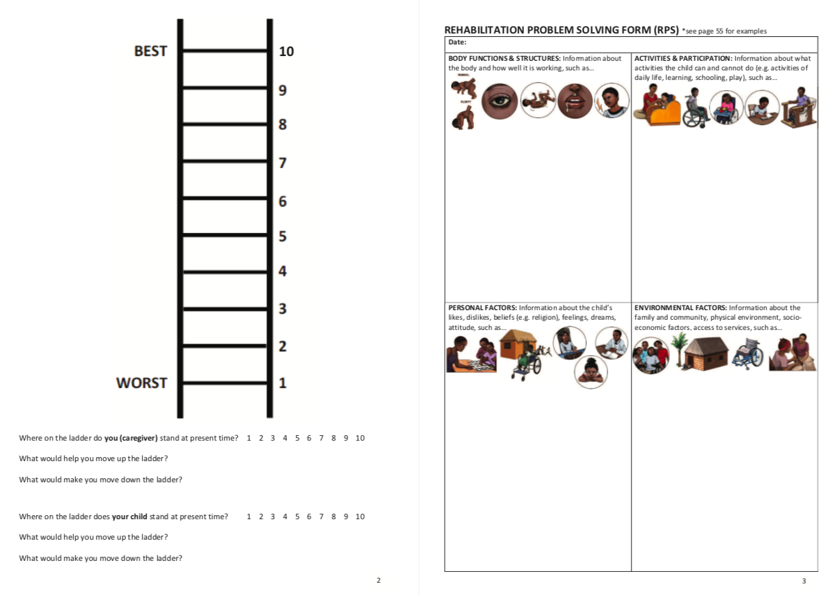
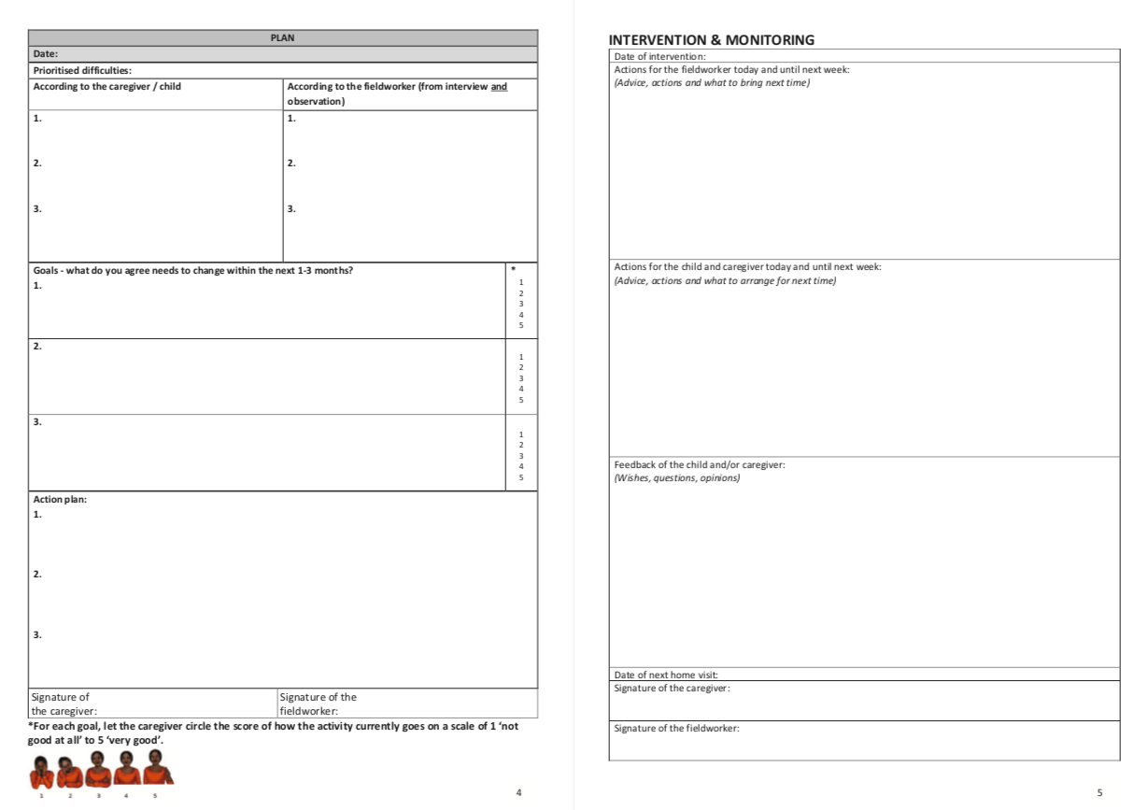
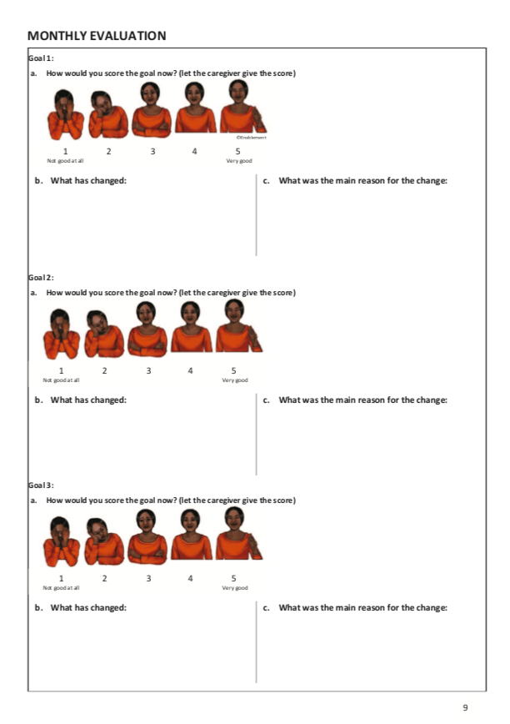
Appendix D
Interview guide interviews fieldworkers

“I would like to ask you some questions about what has happened and changed the past year for you and the family, after the STEP pilot started”.

- How were you involved in the STEP program?
- When did you start working with the families of the STEP program? How often did you have contact? How (telephone, face-to-face, email, other)?
- What change have you seen the past year in you?
- What change have you seen the past year in the children?
- What change have you seen the past year in the caregivers?
- What do you think was the main reason of this change for you (prompts: knowledge, attitude, skills, tools)?
- What do you think was the main reason of this change for the children?
- What do you think was the main reason of this change for the caregivers (prompts: knowledge, attitude, skills, tools, IGA, PSG)?
- Did you use the logbook?
- Can you explain how you used the logbook?
- What did the training, coaching and tools add/change for you in terms of knowledge, attitude and skills?
- Which one or which part was most helpful?
- How does your work as a fieldworker make you feel?
- How do you perceive your relationship with the family?
- How do you perceive your relationship with the PO?
- Ladder of Life scores: fieldworker, child, caregiver

Appendix E
Survey caregivers
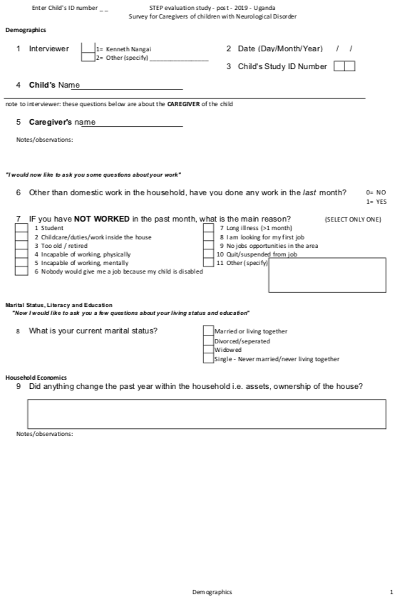
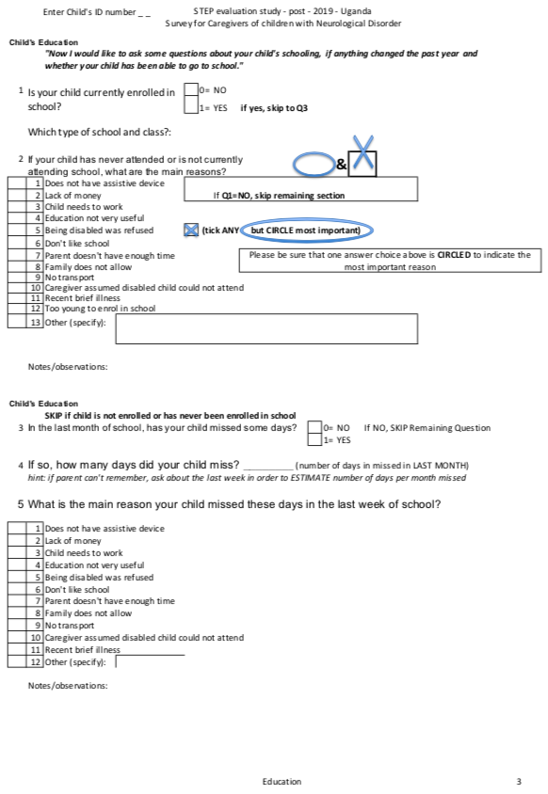
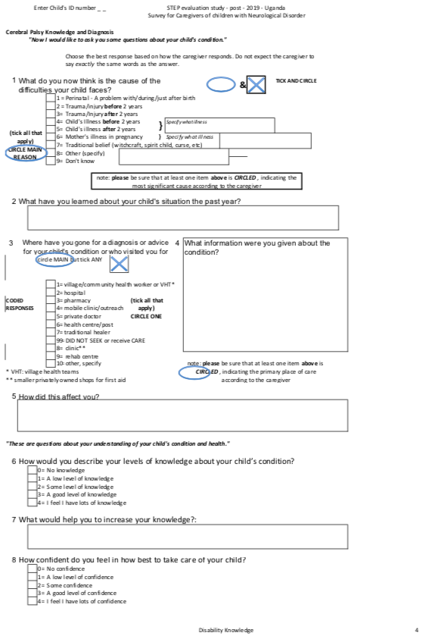
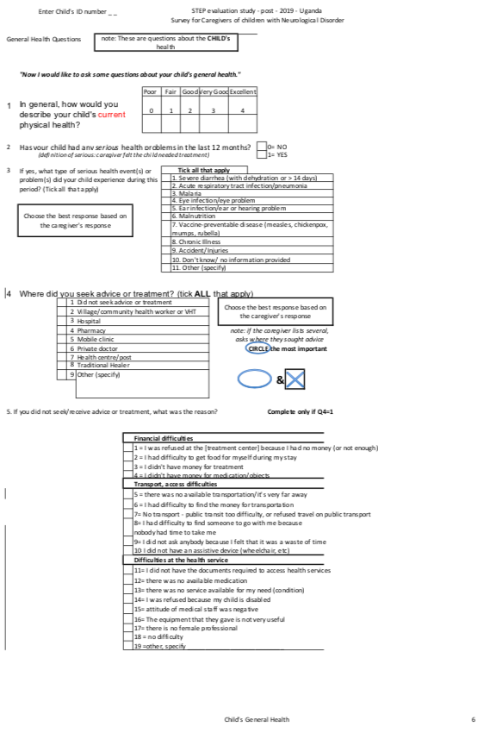
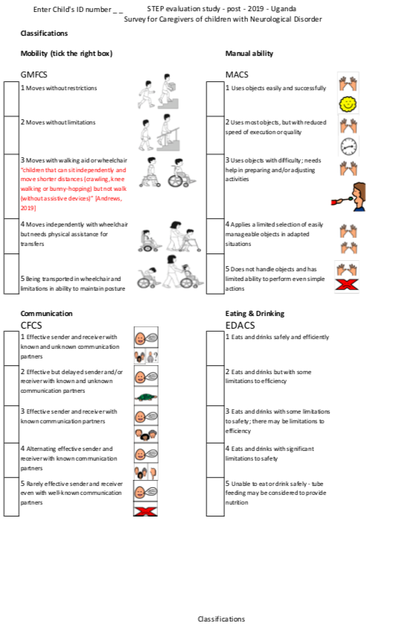
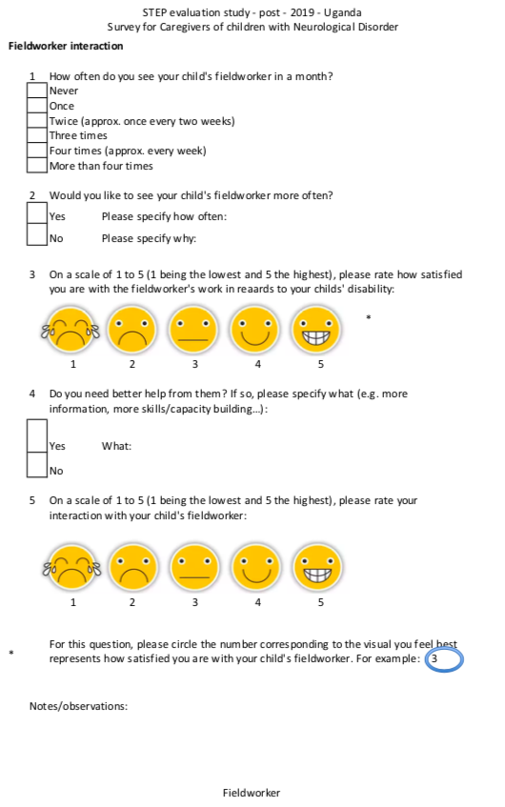
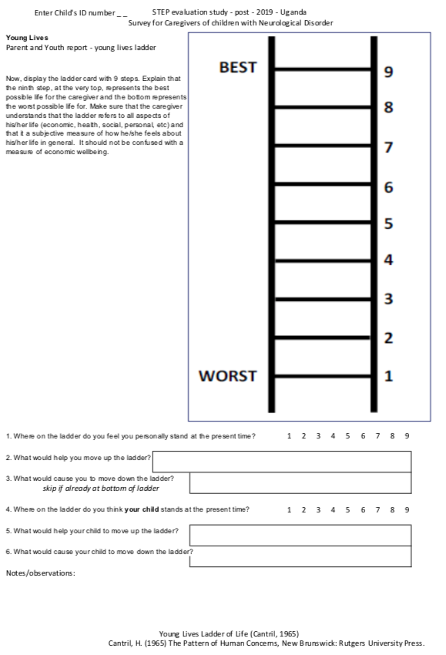
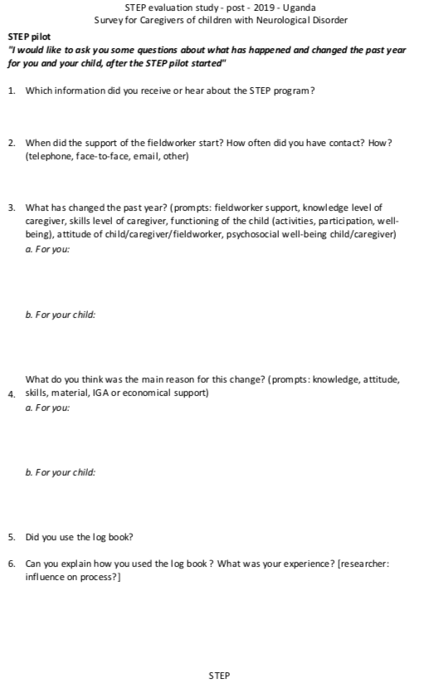
Appendix F
Questionnaire fieldworkers

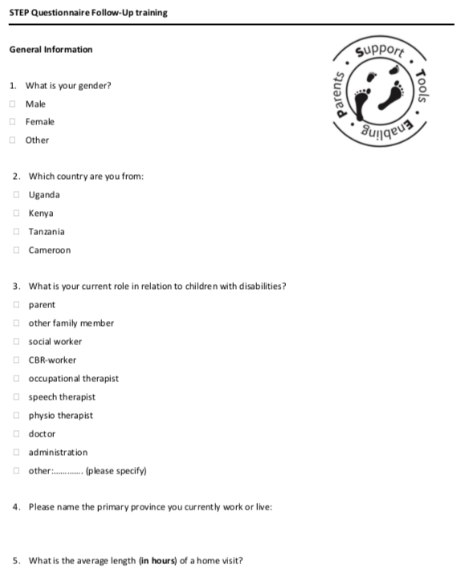

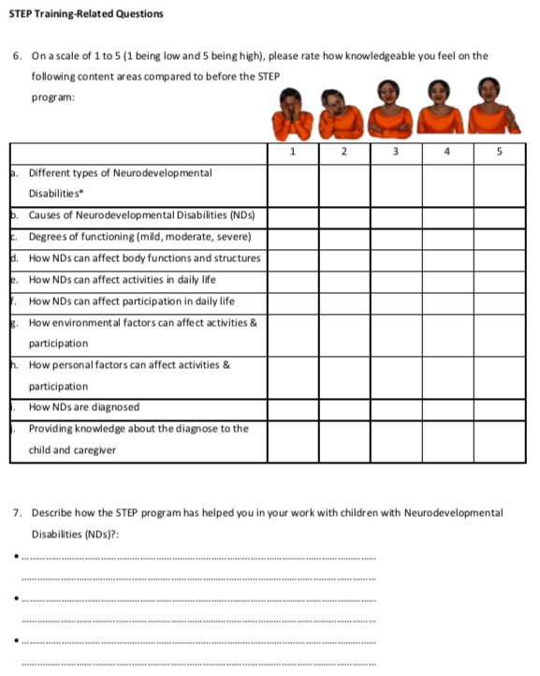

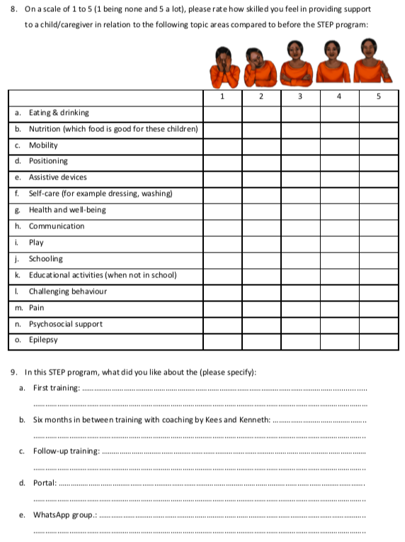

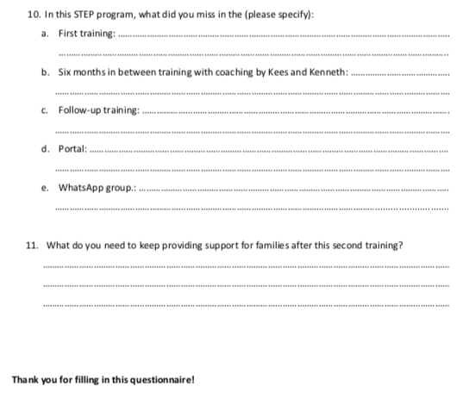
Appendix G
Formal approval director Katalemwa Cheshire Home
Appendix H
Extensive summary Child A

The mother of A rates her level of knowledge at the moment ‘low’, whereas before it was ‘none’: “I don’t understand how he will progress”. Before the fieldworker was coming, she did not know what CP was. The fieldworker explained her “when a child gets sick that young, it can damage the brain”.
The skills of A improved to some extent. He no longer chokes when eating and drinking, can sit by himself with support, sit outside and play with other children, is able to better target his reach, recognises objects that connect to an activity. The mothers’ skills improved as she now knows how to position him, how to feed him. She understands better the cause of his condition. She said gaining “amaanyi” (courage), after previously giving up, now understanding he can progress. She feels more confident from knowing how to take care of him. Having a job would increase her well-being more. She wants more change for the boy. Although she understands more about her child’s current progress, the future is what still worries her: “Anything that can help, any help that can come towards A, I would love it”. “He’s still dependent on anything. You have to do things for him.”

The mother is happy with the fieldworkers’ support at home as the rehabilitation centre is far away, takes time, money for transport and her son is heavy to carry. She feels she now receives the same service at home.
She feels the interaction with the fieldworker is very good and they cooperate well: “she comes here sometimes and when I explain her how J is, she tells me, she encourages me and uses the example of her child. When she advises me, it calms me down.” According the mother, the fieldworker comes 2x/month which she is happy with. According to the logbook, about 11 visits took place (assuming an evaluation and plan was done in one visit), 1x/month. Apart from those, 8 were cancelled, postponed or earlier. These visits are excluding the parent support group meetings that took place 2x/month.
Although the mother is satisfied with the fieldworker, she feels “It’s also good that she keeps improving her skills because learning doesn’t stop, for us both, because it is her I talk to and every time she comes she tells me what to do. Sometimes it’s new information that I hadn’t heard before.” “Everything she knows, she tells me”.

The mother of A scores her life a six out of ten because of lacking income and being dependent of her husband for money. She wants to work and take the child with her. She scores the child at four: “J’s life is not bad other than looking at him as someone who cannot take care of himself, but his life is not bad.” She does feel it can move up more if the support of the fieldworker continues. At baseline, the score was one point higher, even though he reached what she hoped: getting a special seat and moving more easily.

The mother of A feels many things have changed for him the past year. The fieldworker trained her how to feed her child and let him drink. The choking totally reduced, and the fieldworker trained her to do it in an upright position. At the moment, the mother is worried about his hands that are a bit stronger but have uncontrolled movements. As the main reason for the change, she mentions: “her [fieldworker] coming, her identifying us attributed the change to me, coming here. When the fieldworker came here, she saw A, she started teaching me how to work on A, she also told about the STEP team, that there is a team of people that come with her. She was interested in the hardships that come up with me as a result of taking care of A and I told them, I want A to get to sit. And the fieldworker came and did measurements for A and told me A would get a CP chair and she gave the chair. There is a lot of change and I’m happy. Before I had given up on A and just feed A. When the fieldworker came, she gave me courage, “amaanyi”, and now I see that A has a future.”

The mother finds the logbook useful even though she doesn’t read through it and feels ashamed about that. The logbook reminds her. “You cannot keep everything in your brain, if you write it down, you have a record”.

There is a small rough score increase on the COPM: in performance 1.4, increase in satisfaction 1: sitting, eating and drinking, dressing, toileting, reaching out to objects (tries but cannot manage well). The CP chair and exercises created the difference. He can now observe things outside; he wants to go outside. Ever since the chair, children come play with him which makes him very happy. Scores still remain low: “because it is not enough. I see the difference; I see the change”. He recognises objects, sits better, tries to hold but cannot hold the spoon himself. This confirms that goals need to be set in small steps and SMART. Older brother now helps dressing him. Before he didn’t because J was too stiff. Toileting didn’t change. She wanted him to give a sign that he needs to go. “Nothing has changed”. For reaching out to objects, scores are now lower than first time. When showing her the different scores, she says “it must be from my not being able to do something about it”.

Appendix I
Extensive summary Child B

The grandmother of B explains some skills of the child improved. The activities of daily life (ADL) skills due to the grandmothers’ care, the physical skills (walking) due to exercises of the rehabilitation centre and eye drops medication from the eye hospital. The grandmother gets courage from the fieldworker and from the parent support group that the fieldworker set up. It helps her to meet other caregivers. She worries about her own health and living conditions, but also has lots of unanswered questions about the physical situation of her child (leg, hand, eyes, skull) and school opportunities. She wants B to learn to be more independent so she can go to school. Until now, the fieldworker focused only on vision, walking and continence (timed toilet training).

B’s grandmother now rates her level of knowledge as ‘good’, compared to ‘some’ at the beginning of the pilot. She explains: “I understand her a lot, I know when she is hungry or sick or go to toilet or to urinate, I will know. Even when the child is not happy, I will know what is happening.”. She does, however, want more knowledge on what to do with the child’s leg, right hand, eyes, protect the base of her head from falling, and being very concerned. She also uses herbs on the child’s leg and stretches it. Some exercises, she came up herself such as carrying two cans of water to the well to stimulate using both hands. The grandmother smiles and claps when the researchers say the exercise she came up with to practice the right hand is good.

The confidence level of the grandmother went up from ‘good’ to ‘lots’. She explains: “I give her part of my time to play with her, to ensure the child is not in worries, I must engage the child, that she is not unhappy, I clean her.” She was ‘trained’ to love the child from her own child who passed away from epilepsy. “So, I know those children require time, exposing the child out, not to close the child in the house.” “If you continue to see the positive change in the child, it also contributes to my confidence”. She says the child is well, because she can play by herself, eats and drinks well when given, can speak back.

As the grandmother still has specific unanswered questions about some difficulties of B, her satisfaction of the fieldworker is rated three out of five. The fieldworker takes her time, especially calling for meetings, she always inquires about the progress and if there are issues that need to be addressed. She is always concerned about the grandmothers’ and the child’s health. The grandmother hopes the fieldworker can pay the costs for transport to the eye hospital as she needs eye drops to hopefully help the child to see better. The grandmother doesn’t understand well why her granddaughter doesn’t see well, despite earlier visits to the eye hospital.
The grandmother sees of the fieldworker as the rehabilitation centre. She attributes change to both. She hopes for someone that can teach her and B how to brush her teeth, undress herself and control urine and bowel, so she can be enrolled in school. It seems like the fieldworker has been talking a lot with the grandmother, more than working with the child directly. The child walks around in the house during the interview and is chatting with the researchers.
The interaction with the fieldworker is rated four out of five. The fieldworker always shares between her and the rehabilitation centre. She doesn’t know what she could do better. “B is always very, the fieldworker interacts with her well because if the fieldworker comes, she cares and asks how she is, if she is taken well cared of”.
The fieldworker comes 1x/month. Besides this, she meets the fieldworker and other caregivers in the parent support group which is 2x/month. This together is enough according to the grandmother. The fieldworker set up this group from the STEP project: “If anything, they can also talk there”. The grandmother says the fieldworker also has other things to do and hence cannot visit them more often. According to the logbook, about seven visits took place (assuming an evaluation and plan was done in one visit), sometimes 2x/month, sometimes 1x, sometimes not, irregular visits. Apart from those, four were cancelled or postponed. That is, the dates mentioned at the end of the previously meeting does not take place on those exact days. These visits are excluding the parent support group meetings that took place 2x/month.
The grandmother feels the exercise of the fieldworker were useful as she has been taught new techniques from sleeping to be able to walk. What she still would like is a conclusion whether B can go to a normal or special school. She has talked about it with the fieldworker, but without a concrete answer.

The grandmother scored her life a six and her granddaughter at seven. The grandmother now has many worries about her own health (pain) and land problems. She just lost her husband and the landlord slashed the gardens, her food. She is afraid of eviction. About B, she says: “she is always healthy, you see her playing, she is happy, she can sing, she can dance, if you cook food she would say thank you, if you ask her to dance, she dance. That shows her life is not just someone who sits there but is happy, she is always happy.” B’s life, according to the grandmother, would move up if she is able to learn at a nearby school, read and able to see well. The grandmother is afraid of the child’s incontinence and how the teacher would handle her if she spoils herself. Her life would go down if the grandmother would leave her and B has to stay with someone else, because B is used to her.

The grandmother states the rehabilitation centre as the reason for the change. She refused admittance to the hospital as she needed to take care of more children then B. As change from the fieldworkers’ part, she says: “The fieldworker is always interested, and they meet every Thursday with other parents with child with a disability”. Additionally, she mentions: “the encouragement, the fieldworker always encourages me not to lose hope”. The grandmother has many worries about walking, hand, school and landlord which increase her burden. The rehabilitation centre said to monitor the child’s leg as she grows, but the grandmother wants something done in time. “In the last year, the fieldworker has continued to encourage and mobilise parents and encourage parents, like they have been giving trainings with the fieldworker.” She talked a lot with other caregivers about their children. “The group has been important because when you go there you see other children and from talking to those parents and observing other parent, you also learn from their situation. It always makes me, when I see other parent, it makes me stronger, there are children in much worse situation then mine.” The caregiver love the group and are motivated to meet. The main reason for change comes from the advices from the rehab centre, “it’s the parent support group meeting what’s made the difference, but the work on the child that is attributed to the rehabilitation centre.” And the commitment of the grandmother, her care for B.
The grandmother doesn’t read the logbook, but the fieldworker fills it in. According to the grandmother, the language is a problem, “if you are able to translate. Even when we were going to school in those days, it was easier to use a diagram with names or something to make us understand it”. After showing the grandmother the pictures on the CP flashcards, which is the hardcopy version of the RehApp CP, she confirms this is what she means. She nods and copies the movements from the pictures. The logbook only shows ‘walking’ as a difficulty that was mentioned at baseline (COPM), so the changes from COPM scores in the other areas, are not reflected in the logbook and are not attributed to the fieldworker.
The difficulties in the logbook are: does not walk well, does not see well, doesn’t go to school, doesn’t use her right hand, soiling in the clothes. Her walking has improved, but the grandmother sees that the legs are weak, and one is turned to the inside. This worries her as well as B not using one hand. During the interview, the researchers found out B misses a piece of her skull and has an abnormality in her spine, probably Spina Bifida apart from unilateral CP, which also probably causes the weakness in her legs.
Some goals are too broad and cannot be set as realistic with certainty. Such as “she doesn’t see well” versus the goal “B has improved vision”, when it’s not clear what causes this. The reviews at the eye hospital and eye drops are often too expensive for the grandmother, although there seemed to be a positive change from the eye drops. At end line, we find out that the grandmother worries about the skull of B. The grandmother is worried about falling and damaging the brain which was not yet addressed by the fieldworker. The goals were re-set once. The logbook shows seven visits. It is not clear why not more has been written.

The COPM shows no rough score increase in performance, 0, and -0,8 decrease in satisfaction. The difficulties mentioned at baseline were: walking, bathing, dressing, eating and drinking, playing with siblings. Individually the difficulties improved for: walking performance. The grandmother has many questions about walking more stable and stronger, hence probably the satisfaction has lower scores. This was the same for bathing. Satisfaction for eating and drinking improved, playing improved and satisfaction was already at 10 at the start of the pilot. B can now walk and faster although not yet in a straight line. She plays with water while bathing, flaps with clothes instead of dressing, can pick up food now with right hand but cannot hold a cup, eats well, now sees people playing. She also on the other hand doesn’t see the value yet of the child doing things herself “she is still small, so I can do it”.

Appendix J
Extensive summary Child C

For C, some partial skills of the child improved, that is the child can do parts of the activity herself. She can stand in a frame, bring food to her mouth by hand, doesn’t poke in her eyes anymore and she cooperates more with bathing and dressing. The bathing and dressing have not been advised or practiced by the fieldworker.
The mother would like to have more support from the fieldworker, more frequent home visits. Progress seems slower than mother wants. The early skills of sitting and rolling are attributed to the rehabilitation centre. Sitting firm by herself, standing and poking eyes are attributed to the STEP programme. Mother is happy with the assistive devices. She describes having an increased knowledge about her child but rates it lower than before, because she doesn’t know how to make the changes she wants to see in the child. The child did increase, but she hoped for more. The fieldworker provided a walker and a standing frame which she also practices with together with the child.
The mother is frustrated about not being able to work and having to stay at the house, not being able to provide the things (emergency care, foods) that to her are needed for her children. She meets up with the parent support group and hopes for soft loans to start a business. She would like to have schooling opportunities, even in day care, by teachers who understand her child and how to take care of her child. Mother feels confident in taking care of the child. She is overall happy with the fieldworker but believes the rehabilitation centre is more experienced and can provide more support.

C’s mother rates her own level of knowledge a three out of four and explains: “What I want for her, she has not achieved yet what I want her to achieve: walking, talking, she has not yet learned, she can take food in the hand, but she has not yet learned by herself.” She connects her knowledge on how to make changes to what her daughter can do, to level of knowledge about child’s condition. She does indicate knowing what to do and finds the question difficult to answer.
Her confidence level is a four out of four. She scores high as she states she can take care of her child: “I’m confident because I feel I can do anything for her. Like feeding, bathing her, dressing her, even when she is sick, I can take care of her.

The mother scores her satisfaction with the fieldworker a three out of five and explains: “The rehabilitation centre is better than her [fieldworker] what they do. The experience of the people at the rehabilitation centre is more than the fieldworkers’ experience in dealing with the child”. C cannot talk and during the interview, she shoes repetitive behaviour such as flicking of the fingers and sounds. The mother shares that she doesn’t expect to go back to the rehabilitation centre. She feels her needs are addressed by the fieldworker like the walker and standing frame: “She [fieldworker] will always ensure to talk to the rehabilitation centre. To talk about the needs of these children”.
The mother has no problem with the interaction with the fieldworker, which she scores a four out of five: “There is no problem, our relationship is good. At time, we will get there [at score 5]”.
The fieldworker comes 2x/month. The mother would like to see the fieldworker more often, such as 3-4 times per month. According to the logbook, about 11 visits took place (assuming an evaluation and plan was done in one visit), 1x/month. Apart from those, 7 were cancelled or postponed. These visits are excluding the parent support group meetings that took place 2x/month.
Mother wants the fieldworker to make the same improvement as the rehabilitation centre made when she started there, although she does see the differences since the fieldworker started: C being able to crawl and sit by herself. “If she [fieldworker] can add to her experience like the people of the rehabilitation centre. Exercise, like if you are doing an exercise from the rehabilitation centre and compare with the fieldworker, you can see the person from the rehabilitation centre is better”. She also explains: “Since the fieldworker works here, she does quite well, the handling of the children. She really handles children well, even with them, she does well with them.” The mother finds the exercises and advices of the fieldworker useful.

The mother rates her own life a three out of ten. She wants to have a job to be able to generate income herself. She is now dependent on her husband if she needs something and she wants something to do. When her other daughter burned her fingers, the husband did not want to pay for care, so mother went to the rehabilitation centre and they paid for the operation. She gives an example: “But transport, you have to plead with the husband, “please give me some money”. If I can have my own money (…)”. Her quality of life will go down if the husband would leave.
She scores C a two out of ten: “Because the child is still dependent. She cannot do anything with herself, by herself”. Her quality of life would go up “If the child becomes independent, if she is able to walk [mother confirms meaning independency as walking]. Even if she is able to talk”. Her life would go down if the mother would not be with the girl.
About the change of the past year, the mother describes: “She [fieldworker] always comes with new exercises for the child. Like now the child is doing an exercise to learn to crawl, to learn to move from one side to the other [room], so the fieldworker is learning how to do that. Like steps for walking. C was not sitting before, she now learned to sit on her own.” For mother, the fieldworker and the rehabilitation centre are the same as the fieldworker works for the rehabilitation centre [partner organisation of STEP]. Changes from rehabilitation centre and fieldworker are mentioned being intertwined. “She couldn’t sit or even stand or touch or turning or rolling”. When asking which exercises from the fieldworker were useful, the mother answers: “standing, supporting, even walking. Like holding a cup, play with things, play material”. Mother provides the girl with toys from materials she finds in the house: stones, cup, shoe.

C’s mother uses the logbook in a sense that she keeps it. She doesn’t have time to go through the book. She does feel it’s important because it keeps record: “If the fieldworker talks about progress, it is in here. It helps me to keep the records of my child”. The logbook shows that the fieldworker practiced standing with support, taking food to the mouth, drinking hand-over-hand, arranged standing frame and walker and taught the mother how to put in the frame and give her play materials. The mother demonstrated back to the fieldworker how she did that. The fieldworker advised the mother to go to rehabilitation centre to check the foot of the girl that was moving inward. In the action plan, the fieldworker mentioned the use of an insole. The mother took her, but nothing was done about the foot. It still concerns the mother and it is not sure what answers she got. With the support of the fieldworker, the child stopped poking her eyes, is less panicky when practicing standing and now starts crawling. In the logbook is written: “The mother is happy as C has some change”. “Mama is so happy her daughter has a standing frame and it was promised. She says her daughter’s life will change.” The fieldworker has provided the family with some foods to make nutritious porridge for the child. The logbook also states: “She is so worried about the future of her child’s life as she grows older” [mother] It doesn’t say if and how this is addressed. The same goes for grinding the teeth and walking to school, which was too big of a goal.
The COPM shows a significant rough score increases in performance, but not in satisfaction: 2.4 for performance versus 0.3 for satisfaction. The difficulties mentioned at baseline were: drinking, bathing, dressing, standing, walking, playing with sister. No details were given. The little increase in satisfaction is due to lower scoring for standing and drinking, although drinking increased in performance. Within the details at baseline was mentioned that the child had poor concentration and attention and had lost weight. These issues were not described in the logbook. The performance score increased as the child was more cooperative during dressing, bathing and drinking. The mother would like her daughter to stand firmer and walk further: “I’m still at low because I didn’t reach where I want my child to be.”

During the interview, the mother asks: “Where can I take her. Look at her. She can go to school if the people there understand her. They don’t give care unless there is someone there who understands the child”. There is a special school around, but mother says they don’t take care of the children well, hence she doesn’t take her. When she was there, the children looked dirty. Before, child sick every month. “Now it takes a long time apart from cough and flu”. Mother attributes that to being able to keep her daughter clean, having her eat healthy things and doing exercises. When diagnose was given: “my life stopped, I had to stop working, she killed my life. I really got frustrated but I had to get used to the situation”. Was send to rehabilitation centre from the special needs centre. The mother explains: “because I cannot leave and go to work. Nobody would give you a job with a child like C. Having a job would change my life.”
The mother asks questions about opportunities for bringing her child to a day care centre, how to get there. If a day care would exist, the mother suggests the fieldworker to go there and help them with exercises. She also shares her ideas on creating soft loans with low interest for PSG’s. She prefers that above getting life stock. She was offered a chicken by the rehabilitation centre but cannot house a chicken in her rental unit. She would want to buy a fridge, find a shop out and sell cold drinks.

The mother is not mentally supported by neighbours “these are rentals, everyone is on their own”, but she feels supported by the parent support group.

Appendix K
Extensive summary Child D

The grandmother takes care of D. D lives with her and not with his parents. His brother, also with CP, lives in the house as well. She relates her high confidence level to understanding the children’s needs. Her confidence level is influenced, low, by the need to protect the children from other people and from soiling themselves (not being able to take care of themselves). She takes care of five children by herself. This increases her worries, along with her own physical problems. She sees solutions in income generating activities (IGA) to be able to take care of the children and being able to do the work you need to do in and around the house. She sees the support of the fieldworker as valuable: providing advices and exercises such as walking in parallel bars or communicating with your child in all activities. The support gives her hope and courage.

The grandmother rates her level of knowledge of the child a four out of four. She relates her knowledge to understanding the child and what he needs both physically and psychologically. There is no matter of increasing knowledge with the grandmother, only of the child: “Unless it’s him to improve to get knowledge about himself, but myself I understand him”.
Her confidence level is a two out of four and influenced by the child’s need to be protected: “Because children like D and his brother require protection, you can’t leave them alone. When you leave or want to move with one, the other one will stay alone without someone to take care of them. As a grandmother, you have to do work at home so here the children also require some time. That makes it difficult for me. The work now becomes too much because I have to go to the garden, but it has really reduced because of the children. You cannot leave a child alone. If there is something like a burial in the village, I can’t go. They steel children, people steel children. You can’t leave the at home, not out not inside. The children can soil themselves, there is nobody to help. If you are not there, it becomes difficult. Those are things that reduce my confidence in taking care of them. If you have such children, these children reduce productivity because you have to stay with them.” She mentions an IGA would help in that, to have a project at home.

The grandmother is satisfied about the fieldworker overall and about their interaction: “I have learned more from the fieldworker”. “For me I think the fieldworker is sort of a mediator who is between the rehabilitation centre and the parents and easily connects them with what happens in the rehabilitation centre and the parents. About the interaction, the grandmother explains: “The reason is because the fieldworker listens to me and comes up with advises for me. When you have this child it’s like you are in a prison. The fieldworker put in the heart of what you are doing. If you have that child, it’s not an easy decision to just leave him at home. It’s not easy to leave him and go because you need to be there with him. If you look at him as a little bit older, he still needs the care of a baby. You take care of him as a baby, omulabililanga, baby.” “(…) they understand, the fieldworker understands. When the fieldworker came here, all they need and they needed for the child, the material things were provided”
The fieldworker comes sometimes 2x/month. According to the logbook, about 10 visits took place (assuming an evaluation and plan was done in one visit), 1x/month. Apart from those, four were cancelled or postponed. These visits are excluding the parent support group meetings that took place 2x/month. The fieldworker comes in person or calls the grandmother for example to communicate an appointment: “the fieldworker will never take a month without coming here”. “Maybe STEP are we meaning this programme where she comes home and seeing children? The programme is there to help children get better.”
When asking if the grandmother requires better or more help from the fieldworker, she answers to provide eggs to develop the nutrition well. Additionally, she mentions wanting the fieldworkers’ support in going to school “I really want help with school for D because I have hope that D can go to school.” “He wants to go to school when he is able to walk. He didn’t go this year because he was struggling walking but now the child is walking so I have good hope that he can go to school. The school is not very far from here. I have not gone to school but focused on getting him more confidence with walking. He can be escorted to school as he walks alone”. Support with income: “Also the issue of income. I had to go back to the rehabilitation centre, but I didn’t go because of money, transport.” “If they can help do something here, that can generate some money, that can help him”. The therapist at the rehabilitation hospital should inform better about how long the AFO should be used. She now doesn’t know if it is permanent, or for a specific time and what happens after that: “It all depends on the therapist now. She will now determine what will happen at next level”. The fieldworker was the one that recommended the shoe and referred her to the rehabilitation centre [PO of fieldworker].
The grandmother finds the information and exercises of the fieldworker useful: “Because they enabled through the exercises, the practice of the legs and the walking in parallel bars. It has helped him to learn to walk.” She feels the fieldworker is involving her in practicing with D and she motivates D to walk: “She actually wants to see him improving”.

The grandmother scores her life a four out of ten. She sees her life as not the worst but gone down. She feels she cannot take care of herself and her house enough like sweeping. She has severe back pain from an incident with life stock that escaped. She cannot bend well and got some tablets but needs to go to a bigger hospital. She realises her aging is of influence as well. Her life would go up with good medication and treatment for her back. Having to do a lot of work that requires bending, would make her life go down.
She scores the child a three out of ten as he is not sick, but he is not functioning like other children: “he is not able to help himself like talk”. She compares D with children his age; he cannot do similar activities like going to the shop or neighbourhood. Improvement of his walking and being able to go and squad on the toilet would make his life move up. Moving down the ladder: “if he fails to walk, because the child is intelligent.

When asking about the change of the past year and reason for this change, the grandmother explains: “Like on the exercise (walking in parallel bars and practicing for use of crutches) and the assistive devices helped the child. During that time, the child was just crawling and couldn’t do anything but now the child is walking with the crutches. The child walks well with the crutches. Also learned about nutrition and the handling of children i.e. requires being patient with the child. Eating although it’s a bit difficult with the spoon still, the spoon was introduced but the food was still spilled so nothing changed. And the drooling has reduced, that is evident. His clothes would be very wet fast. Now how is dry.” “They [fieldworker] educated on nutrition and not to isolate the child and also keep talking with the child, have a conversation with him. And also, not being tough with the child, not bug [shoot] or beat the child. By reducing the bugging and shouting of the child, it makes the child more confident and not worried every time they see you.” “I have learned more from the fieldworker. When they come, they give me courage [amaanyi] to continue what I am doing with the child and they give me new things. I have been given hope [suubi] that the children will really progress. And the support that has been given for the child, like the crutches and the AFO has really helped the change. That’s it.” “The reason why there is a change in D is because it is done at home. When they call us from the rehabilitation centre, they have materials that they just use there. With this way of walking, if the child needs crutches, if the child needs parallel bar, it is made here, and the practice walking is here. This works better than at the rehabilitation centre. And the assistive devices and also the commitment. To continue with the advice has changed a lot. And when we meet as a group [parent support group], we advise each other about our children”. The main reason for the change of the child is: “the follow up by the fieldworker and also the advice on what next what is required is also enabled to improve D especially visiting him at home. And the other reason is, if you agree with the fieldworker what is required, the fieldworker will deliver and helps you deliver what is required.” “The advice of talking to the child often, play, show colours, that all helped the child improve. Some things she [fieldworker] used to tell me, some I knew, but the fieldworker was emphasising on what she was doing.”
The grandmother likes the logbook: “the logbook is useful. The book records what the child needs, the book is important because it will show what is required, where the child was at and what has changed. If you see the book now, you see where D was at and you see the record of change in the book. With me, I stay with that booklet as my record for D.”

The COPM shows a significant rough score increases in performance as well as satisfaction: 2.2 for performance versus 2.2 for satisfaction. The difficulties mentioned at baseline were: walking, washing, toileting, feeding, dressing. Little details were given, and it is not clear if certain information was a difficulty or something the child likes such as “listening to music and radio”. A higher score was also given (importance) for “playing with other children”, but it is not clear if this was a difficulty or not. The highest increase was for walking and dressing. There was a decrease for feeding because the boy can eat himself but drops food on himself. It seems that the expectations and SMART (e.g. realistic) priorities were not clearly discussed at baseline. The washing at endline (washing hands) doesn’t match with the washing at baseline (washing plates). The grandmother describes the change as follows:
  - Walking: can now walk instead of crawling but not yet long distances. Grandmother believes he will achieve that. “The walking in parallel bars go balance and the AFO has increased the child’s balance.” “If you see when he puts on the shoes and crutches you really see he’s better off. Walking without AFO you really see it becomes more difficult.”
  - Washing: he can make the movements and it takes time, but not thorough. “I think he will build he will get better”, hence grandmother now gives a higher score. “At the beginning, the child was just putting his hands in the water, but I asked him to wash them, maybe that came about that. I already knew. The fieldworker informed us that communication with the child is within all things you do.”
  - Toileting: no longer soiling himself, knows where to go but cannot reach the toilet in time with his current walking and squad. He changed because of teaching him “If you want to do this, here [toilet]. The emphasis of the fieldworker about communication and as a mother I knew that if my child is able to hear, I can teach him, but the fieldworker always emphasised this on how to teach him.
  - Feeding: he eats and gets satisfied but makes himself dirty by dropping food. He doesn’t hold the spoon well.
  - Dressing: if the clothes are not very small, he can dress himself. Before he couldn’t. Fasteners, he cannot do himself. “His fingers were stiff but now it’s not stiff like before. They used to give him seeds and beans to practice by himself. They were taught by the fieldworker.”

D, like most children we visited, has not been sick a lot the past year, just “normal sickness” like cough, flu, diarrhoea or mild Malaria. Grandmother says he needs de-wormers to get better but does not mention why he didn’t have these yet.

Appendix L
Extensive summary Child E

The mother explains STEP as a programme to improve children and help caregivers that have difficulty taking care of their child. To educate caregivers about the child’s situation. “The coming of STEP and the fieldworker here has helped her learn much about E because she doesn’t know where she would have been if it didn’t come. Before you start feeling pity for yourself, hating yourself, give up. So, I had to go everywhere. She just said let me sit home with E. Let me feed my child, give her the medication.” The child is now more outside the house instead of only inside and this also increased her skin colour.
Having another child also helped to decrease worries. She didn’t know if she could get similar children like E. Going to the rehabilitation centre after referral of the fieldworker for epilepsy medication helped her see she is not the only one.
“The other thing she learned, we also come with a message of hope, and encouragement. Understand there are other people out there who care for you, so you are not alone.” Fits and constipation have reduced due to medication, a special seat and advice on food by the fieldworker. The mother did not expect her child to be able to sit in a special seat. The head control of the child improved. Mother rates her knowledge about her daughter at 3/5 as things keep changing for the child and the mother wants more explanation about the causes and what to do “to understand what is happening” such as grinding the teeth, the hands being in fists and the feet “not getting straight”.
She learned a lot from the rehabilitation centre from doctors and other parents when they share experiences. She has questions at this moment about chewing food, the position of the hands and feet, difficulty seeing and how to control the remaining fits. She also would like more training of the fieldworker to handle her daughter in positioning. She would like E to be able to sit alone. Mother rates her own QoL 6/10: “She has learned a lot about E. She used to worry a lot but now she understands the issues you go through as a mother of this child and her worries are gone now.” She rates her daughter at 3/10 “because there are so many things that need to be done about E. The child needs exercises to improve head control, sitting, hands.” The QoL would move up if the fits stop so the child can further develop her eye sight.
The interventions of the fieldworker during the visits mother calls ‘therapy’. She likes it as the child appears comfortable and is satisfied about the fieldworker’s intervention and interaction. She describes it as “a good relationship”. “She really cares. She is always interested in the previous and the now”. “She comes here, she is satisfied because when she comes here on top of what they do, she interacts with the child”. “The visits from the fieldworker monthly really encouraged her a lot. The encouragement, the message from the fieldworker, the counselling you are not the only one. She didn’t even know there were other children like E.” She thought it was an African problem. Mother is afraid to let others take care of her child; hence she doesn’t work. The father believes she is not taking care of the child enough because not all food he buys is finished.
What mother would like more is information in time on what is needed such as a standing frame and AFO’s. She saw this at the rehabilitation centre but is not sure if this would be suitable for her child too. “What they require at a specific stage.” Also, she would like materials she’s seen at the rehabilitation centre, that she’s seen work for her daughter, to be provided at her home such as a wedge as it improves her head control. She sees it as helpful that the fieldworker has a child with CP, which to her helps to understand the mother as she has gone through the same thing. So, the information she gives is “the right information”. What the mother likes, is that the fieldworker trains the mother as well as the child.

Mother likes the log book and checks if there’s written what was discussed. She likes it that you can see the differences in skills and records the child’s development. The father does not read the log book. The log book reflects the difficulties discussed with the researchers at baseline except for the visual problems. Her cerebral visual problems as well as sensitivity to sounds have not been addressed yet. This topic was only touched briefly during the training and did not include suitable actions.

There is a significant rough score increase in performance as well as satisfaction on the COPM: 5 for performance versus 5.75 for satisfaction. The difficulties mentioned at baseline were: eating, drinking, sitting, rolling.

Appendix M
Extensive summary Child F

The mother describes STEP as it is about helping. To help parents of children with disabilities take care of their children.

F is not going to school as she had to stay with him to take care of him such as feeding him. She learned past year that his health condition is not something you can overcome or be healed. “She learned the floppy might not be able to go out.” Previously she felt a lot of pressure for doing exercises with him. She thought this would heal him. The mother sees CP as the brain being held in one place and in time it will relieve.
She is now less worried then before: “I now know what he needs when he needs it”. “Another thing, but F, I understand him”. She does want to learn more exercises or give him with more therapy to provide him with ‘good’ care. It is difficult for her, especially as a single mother, to provide all the things he needs, like good food and diapers, which is costly. She would like a larger house so there is room for him to learn and she is not afraid that people don’t come to her shop because of F “It happens a lot because as a mother you see the bad gaze”. She would prefer to have both a house and a shop and leave him at the house. She is building a house, but it’s difficult by herself. The house lacks windows, doors and a toilet.

Mother believes that more confidence will come from God. If she has worries, she prays. “Even she shares them with someone, but if someone can help her overcome her problems, it’s God.” “The people that come and visit give a lot of encouragement and hope. Like yourself. It gives a message there are people who care and think about them.” “If you have such a child, you get frustrated. Sometimes you want to give up. When people like to visit, it encourages not to give up.”

Last year, the fieldworker came monthly, now it has been a long time and she only calls sometimes. The logbook shows about 6 visits, 1x/month. Mother believes this type of work requires a man to do the passive stretching. Previously she would give a four out of five, now a two out of five. She looks at the fieldworker as a therapist and wants her to come more often to do exercises with F. When she comes, they do it together. She does score the relationship with the fieldworker higher, a four out of five. She likes that the fieldworker listens to her. The special needs school camp of two weeks made a difference in being able to lift his hands. The fieldworker made a difference through her exercises. The mother sees the change and she sees that the fieldworker cares. To her, there is no difference in the support of the fieldworker, the rehabilitation centre and the special needs school.

Mothers’ life would improve if her business would grow and decrease if it collapses. F’s life would improve if her life would improve, because she would be able to provide for his needs. His life would go down if she would not be there.

There is a significant rough score increase in performance as well as satisfaction on the COPM: 6.5 for performance versus 7 for satisfaction. The difficulties mentioned at baseline were: eating, toileting, dressing, rolling. The fieldworker taught her not to use force on F like before but be gentle. She showed the mother how to be gentle and how to do exercises with him. The rest she did was the same as the rehabilitation centre and special school. They never talked about being strong. She says as a parent you also make and see changes: “My understanding with him also contributes to his development”. And seeing other children gives hope: “But when you go to other places that have children with disabilities and you see the environment there, you become hopeful. When you see other problems other people you have, you become hopeful.” “What really builds confidence, even if you’ve been crying all night, what really builds up your confidence, is when you can meet other parents who have a child like this. If you don’t have this opportunity, you could even end up killing your child.” Getting courage came from all: rehabilitation centre, special school and the fieldworker. The special school taught her how to rub F’s stomach, which helped in eating and drinking better. Some scores are low although he did progress, but not to the extend the mother wants as it is not age appropriate. “I’ve learned to take care of him, and I learned to pray for him.”

At the moment the mother doesn’t find the logbook useful because the fieldworker is not coming, not writing in it to see the progress. She would find it useful if that would happen again. Also, the fieldworker takes the logbook with her sometimes, so it’s not always in the house. Now she has lost track of what the fieldworker is doing.

The mother closes with: “maybe it’s my destiny to have this child. So why take a lot of time denying it or crying about it because that’s how it got planned by God. So, I couldn’t have avoided it”.

Appendix N
Extensive summary Child G

For G, we spoke to the mother and father together. It was the only interview in which both parents were present. The father told their story and mother added information and if she agreed or didn’t agree on things.

Parents explain that they think of STEP as “It’s about children like him. There is a way to treat such children”.

Parents explain G doesn’t go to school because he cannot walk and cannot talk. Father went to several witch doctors and took loans to pay them. He is angry with them because he was blamed for the problem, more money was asked of him to do “a better job” and promises were made i.e. that he would walk, but nothing changed and now the family is poorer than ever.

The father had given up before the fieldworker came. He is emotional when telling their story: “G, I really love that child of mine, that’s why I spend the money, just to see that his life changes. But the more I spend the money, the more my heart was torn to pieces, because nothing changed”. The father lost his job and they are struggling to find short jobs and have enough food. The mother sells samosas, but they don’t always have money to buy the ingredients to make these. The boy is home alone most of the time locked in the house [no windows?]. Hence, the parents would like him to be taken to school to not be alone and learn new things like what things are appropriate to put in your mouth and which not: “If there were school for such children, that would be my cry”.
The fieldworker taught them how G could learn to sit and eat and holding objects with a firm grip. She now practices walking with the walker she arranged. There is some change in G. The centre where the fieldworker works, arranged medication to stop his seizures. Ever since, he does not hit his head anymore and falls down less often. The fieldworker comes several times per month. They would like her to come weekly. The fieldworker buys things for them such as a towel. She takes her time to practice with G and they are happy with her method: “She talks well and explains well. She does not have a big ego”. They give her a five out of five: “Because she is free. She has no problem. Cause when she comes, she does her work. She fulfils. Sometimes she comes and says such and such day she’s coming, then she comes”. Sometimes the fieldworker would stay for several hours to practice.

Their confidence level is connected to working. If they have money, they can provide food and support. The food the boy likes is expensive. He would like a job and the mother a capital to grow her business.

Their life would go up if they would have a better job and good business. The life of the boy is scored higher by the mother (four out of ten) then the father (one out of ten). Father wants him to walk, talk and differentiate between good and bad. Exercises would push him up and school. The other relatives like grandmother and grandfather are not supportive and father believes they don’t like the child as they don’t pick him up when he falls. The sisters of G are caring and help him with daily activities.

According to the parents, the main reason for the change was when the fieldworker came: “When these people came, they changed our minds from being bewitched not being able to do anything. They say this people needs exercise, what what, they can work/walk on medicine. It transformed. They made our minds to change so G too” [father]. Mother adds: “The medication, the drugs, the care. Like previously, if you would give him something to eat, he wouldn’t eat. Now if you give him something to eat, he eats. The walking. At first the child had parallel bars [in previous house] so now he has a walker. This has makes it easier for him. The parallel bars were for standing, he would rest on them. With the walker he can easier hold it”.

They find the logbook useful as a matter of keeping records. They don’t read it, but: “When she [fieldworker] comes, she asks questions so we answer, So she writes which means that book is helped for, to know the changes that have come across as in G’s life. The writing is the first day, the second day, it keeps me knowing the changes G would come across”.
There is a significant rough score increase in performance and some increase in satisfaction on the COPM: 2.6 for performance versus 1.8 for satisfaction. The difficulties mentioned at baseline were: toileting, eating, standing, hitting children, washing. The fieldworker addressed most the following areas with advice: toileting (timing toilet moments), taking some steps in the walker, not hitting other children by going outside with him to play with other children. The fieldworker would also advise them to continuously talk with G.

Appendix O
Extensive summary Child H

The mother of H sells bounded notebooks at her home, where she lives with her husband and H. His father is a student and studies abroad. She has a niece who takes care of H while she is working. The niece is paid for her services. She is happy with her because she loves H: “You cannot be happy if you are the only one taking care of H. You need someone to help you”. She can now go into town without worrying for her child. Part of the interview is in English and part in Lugandan. She was told that STEP is about sending fieldworkers to help children at home, do exercises but not daily. If there is anything that can help her, they will help like shoes or CP-chair.
“H limits me to do things. Cannot control. When the baby’s happy, momma is happy.” H doesn’t go to school because of a lack of money. Mother knows he might not be able to follow all activities, but he can learn from being there and meeting other children which he likes a lot. “I think I can get another change for him.” “When he sees other children, maybe he can do something I didn’t know.”

The past year H has been ill with Malaria. They went to a local clinic for support.
The fieldworker comes once per month, the mother would like her to come twice per week. The logbook only describes four visits. In addition, the STEP coaches visited the house at least three times with the fieldworker. In the past, a different fieldworker was involved which explains less records on home visits. The mother is satisfied with the fieldworker (five out of five) and scores the interaction a four out of five. She finds the information she receives helpful and feels she is involved in the process. She is happy with the CP chair [wheelchair] because H now has friends that come to get him. Now she can also explain to others what her child has. Her knowledge increased on what he needs “but you can’t go very far”.

The mother scores her life a five out of ten. She is trained and she has ideas, she has a small shop but no capital. She scores H’s life a six out of ten and says this won’t get higher due to his limits and the needs for constant care. She does believe he can go to another step when he is very happy such as when taking him to school.

There is a significant rough score increase in both performance and in satisfaction on the COPM: 3.2 for performance versus 3.2 for satisfaction. The difficulties mentioned at baseline were: sitting, eating and drinking, toileting, dressing, bathing. The fieldworker addressed toileting, feeding and bathing and she arranged a wheelchair for sitting. He no longer chokes when eating or drinking due to better positioning and his arms and back became stronger with the exercises. She doesn’t expect him to eat independently, but she sees him trying by opening his mouth. For the bathing, they tried together with the fieldworker: “When we came here it was a big problem, crying. Now we change the water, position, make it fun, we learned the soap went in his eyes. We start from the head. We make sure the soap doesn’t get in the eyes. So, he doesn’t cry too much now”. Mother says H is happy with the wheelchair. She learned many things with exercise she can do herself as a difference. She also liked the counselling and learning to be strong(er) about her baby, that he can gain if she has energy and then they could both be happy: “To be a little self-pity, no self-pity, no feeling of that, feeling of guilty, not need to feel guilty”. “When fieldworker talks to her, she feels strong. When I hear, I now learned, we came with the message of hope, but I know that are other people that are also concerned about our problems. They have their heart on the children.” There is also another fieldworker coming to her house, who is also a mother of a child with a disability. She would like someone else to do exercises with her child as it hurts her thinking it might be painful to him and she wants more for him. It encourages when the fieldworker comes: “amaanyi”. The differences the past year come from the visits, from the exercises. Practicing communication during play and daily activities and strengthening his head balance and arms. “Many changes, but I’m very happy for communicating. H cannot talk but you understand what he is ‘talking’. The difference comes from exercise, that’s a fact”. Her satisfaction with the fieldworker is five out of five but interaction is four out of five which to her is due to the fact that it took a long time for the wheelchair to come. “When we discuss something, they don’t give it. They agree the child needs a wheelchair. She keeps calling. To do better is like this. If you come here, H needs a CP chair. Don’t only talk about it. For mothers, we have more pain for our child then the fieldworker. That’s why I called you [points to STEP coordinator] because I’m the one who has the pain. Because the mother, she knows the situation.” She would like them to not only talk about it and make a plan, but also act. She also finds 1x/month visit and sometimes calling too little. [during the visit in April, she explained that they talked a lot on the phone and the mother was also calling the fieldworker to keep her informed. That interview was together with the fieldworker] She mentions as main reason the exercises of communication by words: “Before I was communicating with him, but now I know it’s important”.
She does not use the logbook as the child is her ‘book’. She does feel it’s important because the fieldworker can come, look at the goals and see how it changed. She wants the logbook because her husband can also see what is happening with the child.

Mother scores her knowledge level a three out of four: “Because H has changed his situation. I can now ability to explain to other children about his condition. I can explain why H is in that condition. Now I can say H has lived this according to the way he is”. Her knowledge would increase if she would feel fully confident about his condition. At the moment, she doesn’t feel more confident than before, but confident somehow. She would like to make more money so she can provide anything for him, without having to ask the father. “As a woman, you really have to do something that keeps the husband attracted to you because he can leave.” “The financial constraints can chase away the husband. The responsibilities of a child with disabilities exceeds his capacities to provide for the child. Sometimes you don’t tell him if he needs pamper like ‘please he needs a pamper’.” She feels respect from her husband when she arranged something herself, like the chair.

She is the chairman of a parent support group on request of the fieldworker. She sees a difference between caregivers that work and don’t work, which makes it difficult to work with savings systems in the group as well as caregivers coming from different distances. Some caregivers can’t come because they have to stay with their child.

Appendix P
Extensive summary Child I

The fieldworker classified I as ‘mild CP’, but from training, she is more likely to be ‘moderate CP’.

I lives with her mother, father, twin sisters and older sister. She has the age to go to kindergarten, but mother is afraid she will give the teachers a problem as I cannot feed herself. There used to be a maid in the house that helped mother, but she recently resigned. Mother feels a lot more pressure because of this. It has been a while since the fieldworker last came, over two months ago. Previously she came 2x/month. Mother would like her to come more often.

There is a significant rough score increase in both performance and in satisfaction on the COPM: 5 for performance versus 5.5 for satisfaction. The difficulties mentioned at baseline were: sitting, eating and drinking. The logbook only shows the rehabilitation problem solving form and one home visit in June. The fieldworker focussed on communication with words and face as well as rolling on the bed and sitting. Goals were written quite broad and not SMART, but this was the start of the logbook and parts seemed to be missing. Practicing with sitting is not written in the logbook but described by the mother. I can now sit and eat and drink without choking.

The fieldworker taught the mother how to practice sitting, that progress takes time and is about enabling the child to do things. “She might not do everything, but it’s about maximizing to do best. So that was new for me. Previously, I had given up.” The doctors, when I was young, told her exercises would awaken the brain, development would be slow and not like other children. She started going to the hospital for exercises, but it was hard for her to go and she got penalties if she didn’t come. So, she got tired of going. She went to different hospitals and they referred her to the rehabilitation centre which is nearer to her home and where she could meet other mothers. From there on she started to accept the child’s needs as the only solution. She copied what she learned there at home but also gave up and stopped going at the rehabilitation centre. That’s when the support of the fieldworker started [the fieldworker is employed by the rehabilitation centre]. She felt her interventions were not different from the centres she had gone to. “The most important difference that fieldworker did was to give me hope, amaanyi. When she would come, she would also work on the child at home and trained me on what to do with I when I have time.” I is too heavy to carry to go to the rehabilitation centre. Often, she comes for half an hour, coaches the mother, practices with the child and talks with the mother on what to do. Mother would like her to stay for an hour. Sometimes the fieldworker comes with a therapist from the rehabilitation centre. The mother is given advices like a reading chart or chart with pictures for communication, but it was the mothers role to make it. This didn’t happen yet. The mother finds it difficult to initiate this. It would have been easier according to mother if the fieldworker would have made that.
She feels the fieldworker listens to her and is not hesitant with the child, is always compassionate and involving the mother.

The mother finds it difficult to rate the Ladder of Life and feels sad: “It puts me in deep thoughts”. She scores I at five out of ten as she has to learn many things. Mother wants to take her to school, but after she learned to eat by herself that mother packed for her. She wants her child to be more independent i.e. coming out of bed, give a sign for having to go to the toilet instead of soiling herself and letting her mother know she’s hungry. Pooing can be controlled with timing. Shouting at her would move her life down.

The mobiliser of the rehabilitation centre came to her to explain about STEP: “At first I thought, I’m tired of all these exercises. But when the man explained, she thought ‘hey maybe there is hope in this one’. So, it was about helping the child. They told me this programme is about helping children like I to improve”. In the beginning the change was big and gave her more courage and hope [amaanyi and suubi]. They practiced sitting, she was told to always communicate with I: “That also changed I, because I hears everything you tell her. She hears and understands”.

Mother reads the logbook to see the progress. It motivates her to reach the goals they set. The fieldworker writes down if she believes there is any change, is able to guide mother on what to do.

Mother scores her knowledge four out of four as she understands the child; what she wants and how she feels. She scores her confidence also a four out of four because she can take care of her child and the child goes where she goes, not staying in her bedroom and always engaging her. She feels I is happy and does her best to help and wanting to get better “Not just sitting but do something about it”. She would want I to increase her confidence by also being able to stay with other children and meeting other people.
Appendix Q
Extensive summary Child J

J lives with his mother and father and siblings in a small house. Inside the living room is a sewing machine on which mother works to earn some money.

Mother explains STEP as: “She knows she calls it STEP up. It is a programme to help her take care of her child. It helps the caregiver so that the child is also aware of interpret the words directly. If you help the caregiver, the child is well of”. Previously it took a long time and money to go to the rehabilitation centre. Now the fieldworker comes at home and the support is more frequently. “She [mother] has continuously been given exercises. When they tell you something, every time they bring new information and new techniques. This change of knowledge also enables the child. New information pushes the child to another level. Previously she did stretching but now she picks and put in something. That picks the child’s brain: "omwana akozesa obwongo bwe”.

She scores her knowledge a three out of four because she knows what her child needs. Her knowledge is for now and not for the future. Her knowledge would increase with that information: “What would push me to fight, is when taking thru information about the future would look like”.
She scores her life as a six out of ten because she didn’t go to school and would like to be a counsellor or have more capital and her own shop. She is happy her husband is with her, because she has seen many husbands leaving their wives and the women having to lock the children in the house.
J’s life, she scores at seven out of ten because he is self-aware and can indicate needs. J hears this and wants to point as well: eight out of ten. It would move his life up “if it can be discovered what he is capable of doing”. She needs people with experience with similar children to give advice and examples of that.

She scores her confidence 100% as she says it’s the mother that needs to take care of the child. She does feel his needs are many while she also needs to make money. If it wasn’t for J, she would be in town tailoring. She says most parents don’t want a maid to take care of their child, but it is needed to survive. I would make her stressful though, afraid of misunderstandings about how to treat the child. Having an alternative income that also allows to have time to take care of the child, would increase her confidence. She would like a shop by the road with enough room for J to stay as well.

She is satisfied about the fieldworker and their interaction (both five out of five). The fieldworker comes 1x per two months. She would prefer monthly visits if the fieldworker would only focus on physical. If the focus is on education, several times per week would be better. The fieldworker classified J as ‘mild CP’, but from training, he is more likely to be ‘severe CP’.

There is a significant rough score increase in performance, 2 points, and a decrease in satisfaction on the COPM: -1,25. The difficulties mentioned at baseline were: walking, holding food and eating, speech and reading and toileting. Priorities were set too broad and scored combined at baseline. Hence the evaluation needed more questioning to identify changes. If the priorities had been more specific, it would have been easier to identify change. The re-scoring reminded the mother of other steps within the activity that she wants him to achieve such as he can bring hard foods to his mouth, but not soft food. She also realised that she scored too positive at baseline, hence the lower scores now. Some of the activities were taught by the mother such as reading, names of colours and holding food, but she doesn’t consider herself a good teacher and wants him to go to school and learn how to teach him better. The fieldworker has a background in teaching. The mother went to a school, but the teacher said he wouldn’t keep up and needed to go to a special school. There is none nearby.
Some activities did change like being able to say “soosoo” for having to pee and some other words, but the word is not clear yet. Mother wants it to be clear also for people that don’t know J. The fieldworker taught J to use the word in combination with the gesture. She also taught mother how to put J in the standing frame and what the rationale is of the standing frame. His standing is now stronger and less shaky, and he has a wheelchair so he can go outside with his siblings. She learned that if she keeps on working with her son with the things she is told, he will improve including his understanding. What she learned from the fieldworker was not different from the rehabilitation centre. Mother says he doesn’t need the passive stretching because he already has movements in his body, in contrary to what she was advice before the programme. The fieldworker advised activities that were, according to the mother, more functional.
The mother feels every therapist, including the fieldworker, has specific knowledge and added value and know different things. The mother feels that through the fieldworker’s visits, J values more the exercises the mother is doing with him and doesn’t see of it as punishment. Mother would like more advice i.e. like a video we showed on practicing standing and letter poster on the wall. This encourages her “It enables her to give a picture of another one [child], what is possible”. She would also like a low CP chair for church. She feels this appears better than a wheelchair as church is not only for prayer, but also for social interaction. It was already requested two months ago, and measurement took place, but not the fitting yet. She feels the rehabilitation centre, when treatment at the centre, doesn’t take into account the transport costs and weight of the child.

Mother explains she sees parents get tired of explaining causes to other people about their child, so hide their children. For her it’s different, because people know the causes and she has some ideas of what to do and hence, understand her worries. She would very much like to be a counsellor for parents. She sees the importance of the child getting outside the house, having a wheelchair to move out but she wants ideas on education. She wants him to go to a school that can see what he is able to do and what is the next level. To look at his strengths and build on that, not just academics, i.e. playing the piano.

The logbook shows about 8 visits and provided thorough and detailed information. The fieldworker focussed on sitting and standing exercises and with an assistive device, indicating to go to the toilet, drinking from a special cup, use of the hands for example writing. Advices were given by the fieldworker together with a therapist from the rehabilitation centre. J has been sick for some weeks in which no practice was done. There were some frustrations in which the fieldworker advised the mother to got to the workshop at the rehabilitation centre but didn’t get the adjusted wheelchair home with her. The logbook records an injury he got from the wheelchair but not the cause and how it was fixed. The wheelchair was advised in September 2018 and went back and forth several times until final adjustments early April 2019 were done. She finds the logbook important because she is able to follow the plan and it doesn’t get lost. They write down what they agree on and see how the child is improving.

Appendix R
Extensive summary Fieldworker 1

The interview with fieldworker 1 is in English and sometimes in Lugandan if she cannot find the words in English.

Fieldworker 1 shares that for caregivers it’s easier to live in a village then in town as in town you have to pay for water, electricity and rent [to the researcher’s knowledge, rent also needs to be paid in the villages and often, there is no electricity].

Within families, she looks at situations or questions she can act upon by for example finding out what parents did or didn’t do. If she cannot address a situation herself, she will ask the caregiver to come to the rehabilitation centre or refers for example to the workshop for devices. She does the same with complications like mental or health issues: “That are just those things I couldn’t do as me but find out from other people who know the condition better”. She requires consultation herself with questions from caregivers for example about school and the budget for that. But also, from therapists of the rehabilitation centre. She often brings an occupational or physical therapist or orthopaedic technician from the workshop with her to the home visits at times or discusses before going on home visit: “I talked with them about the child we will see and the goals and we build something to build on the goals and focus based on the goals set”. Some of her families are over an hour away by motorbike. The therapists teach her further on what materials to use and how to do it. At the home she advises the caregivers what materials to use with what is there: “It’s like when you don’t have something but you have an option or you find something that looks at that, we look at what we have and somehow look like what was here [at rehabilitation centre] that is some of the things I try to do because I have seen it here and I ask an OT [occupational therapist] person what do you think of this. They can then for example advise the blanket has to be at this level or this depending on what we want to portray”.

The fieldworker shares that after the training, it took some time to locate the children and caregivers, so therefore started a bit later. Also, sometimes parents would call to cancel a meeting and suggest a later date. Some are living close together and others more scattered so couldn’t be visited as often. Also “Some parents needed more time to talk to. Some parents had an easier time following steps than others. That also got to do with it”. She was able to visit three children per day of home visits. She would visit if parents call. What they talk about during a call depends on somebody’s needs for example to say ‘thank you’, child is sick so mother doesn’t sleep well, “Some also call to say ‘how are you doing, I didn’t see you this time’”.

The change in her the past year of the pilot was gaining more skills. It was a new field for her. She learned to do and explain many things and adjust to that. She believes was she explains is close to what the therapists do. She became more confident in expressing herself [explaining to the caregiver] through the learning, the consulting, the trainings: “When you always talk about something you know you are confident. You become peaceful with yourself. It came through the training and learnings. It means you are able to deliver. Me knowing what to do, it makes you have confidence. When you have what to deliver and know what you deliver is appropriate, it gives confidence”. She learned to work in a company with many people and learned from the company and the field.

She wants more skills about what to do in certain situations with the materials that are around for example if there is no wedge. When you are creative, have new knowledge, even little, the caregivers are grateful according to her. “Every day is a day to learn. To give someone hope, everything will be fine, they are able to believe you I am very happy, I am grateful, when she like this or like this. Somebody gets some confidence. Not that you created a whole world for her, but the small offer is all not to be on a rush for change but always help her to see more, appreciate the little. Compare the life before and compare with the present.” She will ask colleagues about topics for a specific child such as nutrition or consult on issues for seizures. “So, they explain, and you are able to think something”. She feels the caregivers now understand the condition of their child and no longer believe it is witchcraft or a myth. They have some knowledge on what to do and when like for positioning. They are no able to compare the situation before and now and what the benefits are of this change. Some parents got more confidence in taking care of their child and are able to connect to the child. They meet other parents and become friends (in STEP training or at the rehabilitation centre for example wheelchair fitting). “Sometimes it is the person with the same condition and say, I am not alone and not lose hope”. She connects caregivers together and for example if they cannot contact a certain parent, they would ask another one. “It’s like a centre for them to learn from each other, support each other”.

The fieldworker cannot say all the children changed. The one that changed, did not change always because of her, but a combination of services that contributed like the OT she asked to come with her. She explains a situation in which the mother gave up and now saw the change. Some mother joined the STEP training and are doing the activities learned there: “They put things in action. You just help them to keep on doing that. Maybe giving them the appliances, just that.”
To her, the STEP programme brought services together and home. It was easier for the caregivers with services at home because of no transport costs, it is easier for them to put things into action within the home environment and practice it more often. Materials are not only used in the centre anymore, unless it needs adjustment. “Through STEP it was easier to do these things at home”. She explains the situations of a child who was malnourished, and the mother didn’t know certain skin colour and hair were signs. The mother learned to recognize this, understand the condition, was taught how to make nutritious food first. “Then she had her own needs like stand, but she was not strong enough. She need a platform to stand and to learn to, the mother needed to gain that knowledge, at least a little help, some counselling and guidance, because she saw it as normal but it opened her mind that her child needs this and through the help of the nutrition and the help of the whole team helping me out, at least the child was able to be not like the best but at least better than what it was”.

The reason for why caregivers respond in a different way, to her, is because they have no doubt in what you say and will try it out. They want to try it out. They don’t need pushing or more support. “She is usually doing these things alone. Now you can encourage her, you tell her to continue what she knows. Now let you do at home.”

The fieldworker describes the logbook as: “It is useful because it helps you to know what you decided on, what you have been telling, what you have changed, why you changed it”. It’s easy to get back to and remember: “It keeps info in a way that even when they go to another centre there was someone who used to come, this is what it looked like, this worked or not.” Not all caregivers could read the logbook. It does help the caregivers also to explain to other people. She suggests the opportunity to take a picture of the logbook to keep on her phone as they stay with the family. She also suggests adding more pictures in the logbook for parents: “Some things, parents learn by seeing”. Or the ability to tick the boxes of preset goals. “So, what you choose, you put in there in a place they can see. Pictures are more attractive. Or pictures of the child in a CP chair. Or after getting that chair, take a picture and put it there.” She used to fear the logbook because she did not know what to write in it and felt her first goals were not good. She was afraid her goals were not realistic when the coaches would come along and see the logbook and it’s in your handwriting. “I learned to use it, I now love it and I write it when I go. I changed some of those books, because I didn’t like what I have written.” She said the first days were not so easy and she was nervous on the first home visits. She did enjoy working with the coaches: “Confidence, when you know what to deliver. When you don’t know what to talk about, you just keep quiet. But the logbooks, their own story, I love them, write in them, thinking about them, what I have learned from you, the training, the OT and PT department, putting into consideration and then I sit down and write.” She felt of it as learning the hard way but that the coaches also saw her improvement. It gave her food for thought. Sometimes she said being reluctant, but “If you have teachers, it makes you grow at some point”.

She doesn’t use the Portal, she couldn’t manage. She had the app, but a new phone and not enough space at the moment on her phone. She suggests having flashcards. She connected now herself via text messages with fieldworkers from the different countries and are planning to do things together such as going on home visits together to learn from each other.

How the visits changed the fieldworker: “It changed my attitude towards a lot of things like you have said something is unrealistic but then you tell me ‘can’t you…’”. She sometimes felt a bit ‘low’ from the coaching of the STEP coaches, but it made her see the real things that work by showing her. The knowledge was new for her, she could try it out with the coaches and see how it works. “You are able to explain. He is able to show me, I am able to see. The visits is where the whole learning come from”. She learned to set smaller goals from the coaching and what needs to be done first. She now recognizes these needs. She feels this type of working is new to parents and what they needed: “They are already frustrated, work on what you have told them. Make them a little bit feel relieved so work on the main issue. Looking what they have, the home hasn’t so many things and then talk. They will be ‘thank you’ on what you have given them. They are happy with the child and the child look cleaner, they have smiles, they believe in you. They can tell you anything made them trust you. Not by only bringing the knowledge but providing something they don’t have.” She recognizes the importance of generating own income by caregivers, making the mother feel comfortable.

She feels the training was important, also meeting people from different countries and sharing different experiences. Sharing from different professionals and fields. It’s about learning from each other. “The trainings have been a platform for learning more than what you know. What we learned, we go and the trainings come back and we are able to give feedback.” The trained showed her the how and the why. Hearing the different stories and cases encouraged her and compare to her own thought. This gave her many ideas to think of. The videos helped and looking at the life after the training. “It’s all about learning and interaction. Share, learn from others, you try it out and then it works.”

If she would now have to organize the STEP training, she would use the same topics, the logbook but also add home visits. Include children and caregivers physically and practice key things such as positioning and feeding. Include some of the objects they use at home in the training such as eating utensils and “look at what is hopeful and what not. The child and caregiver should be in this because they are the ones living this life”.
She feels she needs knowledge on more health conditions. She used to rely on a lot of people for support but feels now she can do it herself. Reaching the families is sometimes hard and risky as they live remote and it can rain hard. That made her life a bit stressful.

The responses she gets from the family vary with individual differences: “I say, there are those who love me to go to their homes every time so maybe that shows they like what you do”. Some of the caregivers have become friends and they talk “what is beyond the child”. That made them open up more to each other.
She finds her colleagues supportive which makes her work more smoothly. The head of department and programme manager are interested in her work, they read the reports and help her. “They stick to my plan or else they ask me”

Her life, on the Ladder of Life, went from 2 to 8. She learned many things about many different people but feels she needs more to learn. She puts herself at 8 as she sees herself as a coach and not a therapist. “At least I’ve managed to bring a smile”. She can explain more in detail to the family, use simple language.
She scores the children from 4 to 6: “There are things that still finding ways to how to make the child better”. It would move up if the caregivers understand the goals, work on it and focus on one. She saw the children learn a lot, step by step, slowly.
She scores the caregivers from 5 to 7: “From what they are doing, they added a step to what they’ve been doing, they brought some of the things home now. They are adding in more things that are better for the child than usual”.

Appendix S
Extensive summary Fieldworker 2

Fieldworker 2 is the mother of a child with CP. She became a fieldworker after the STEP training. Many of the caregivers she supports mention the advantage of her having a child with disability herself and thus understanding their situation.
Her aim is to guide and counsel parents on how to handle feed, play with their children and give them more hope. She set up the parent support group to enable the caregivers to help their children more. She was trained before STEP on feeding and trained other parents. She learned from STEP, compared to her other work, more than stretching. “So many things I learned during the STEP training. With the rehabilitation centre it was about stretching children but now it encourages much more to improve positioning and new skills on epilepsy.” She can only visit the families if the rehabilitation centre facilitates her and this is not always the case. She would like to visit the families more often, at least 2x/month. “These visits are ensuring what the parents are doing, seeing progress and advising what to do next.” She sees the PSG as one of the ways and that when parents see other children, “Amaanyi” [courage].

What changed for her the past year is continuing to understand the children. If she now finds a child outside the STEP programme, she has ideas on how to start helping them: handling, positioning, feeding. She gets confidence from caregivers that respect her. If they respect her, they respect the things she does, agree with her ideas and cooperate with her ideas.

She is at 7 on the Ladder of Life, because she sees change in the children she is working with i.e. better hygiene, improved eating, now having assistive devices. She wants the PO to agree with her work and support her better. She sees that parents are frustrated if she has a plan and appointments and she can’t go. She won’t give herself a 9, because she has to keep on learning “I still have many things to learn” i.e. understanding epilepsy “Because I still have problems if the parent says the child has convulsions, I don’t know what to tell the parent about it”.
She wants her employers to be more involved in her work, ask about her work and take into account and follow up on her advice. That would motivate her. “When my advice is not listened to, that really pushes me down”. She also doesn’t want to work alone, but also exchange and learn from others. The WhatsApp group is not attainable due to social media tax in Uganda and poor phone network.
She feels that caregivers see her as useful because they contact her if they have questions. She does not tell caregivers the reason why she cannot visit sometimes: “It’s immorally right to tell them”. She hopes they don’t get annoyed and understand she also has other work. She feels that when she visits families, they are happy to visit her.
She sees the changes before and after STEP in the caregivers and children i.e. decreased stress because now, they have hope that someone is coming home and checking on the child. The rehabilitation centre is too far for them which influences the progress of children. The fieldworker sees commitment from parents. They do it when you tell them something. Assistive devices helped children to not only spend most of the time inside the house and now gotten friends. The stress of parents got down because of that. Other children won’t come when the children lie inside the house. The parents made friends through the PSG and now say they are not alone. She also made new friends. It helped her, having a child herself: “Like me having a child like that, I saw some changes to my child, and it was also my motivation to see those changes in other children as well.” STEP added to her knowledge about other children.

The fieldworker finds the logbook useful for her and some parents as it reminds them of what to do. Some don’t look in there and just keep it. “I tell the book is about the child, it’s a book to help you like if we agree on for example what to do for the child, what is needed to provide, it can remind them in the book what we agreed upon”. The PO wants to see the logbook from time to time. She then has to take it with her. Some caregivers stated to the interviewers that they don’t like missing the logbook. The logbook enables her to remember the plan that they developed previously. She cannot access the portal due to poor network.

The coaching enabled her to do better. The RehApp CP helps her remember if she goes to the field. She prefers the phone over hardcopy information as she can also access it offline.
Appendix T
Extensive summary Fieldworker 3

The interview with fieldworker 3 is in English and sometimes in Lugandan if she cannot find the words in English.

She sees her role as a fieldworker within STEP as “Maybe solving, listening to parents’ problems because some just need encouragement, maybe they need someone to talk to, to listen to them, sympathize with them, interacting with the parents about their child”. She feels that for some children she can do nothing, especially children with severe CP. She plays with the child and carries them, so the caregivers see she doesn’t ‘despite’ the child. For her STEP is about training the parents, help with IGA, creating awareness and improving caregiver’s knowledge about CP, assessing the child. It’s about teaching the caregivers how to do certain daily activities with the child and look for alternatives if needed.
She is also involved in finding schools, getting information from them, talking to teachers and motivating them. This is also a task of the organisation she works for but started after the first STEP training.

For her the communication with the caregivers by phone is daily, the home visits less frequent, about 2-3x/month for each family as she visits other families outside of STEP and has other activities in the organisation she needs to do. There is also another fieldworker in the organisation, a mother of a child with CP herself, who visits the families more often. She finds the communication overwhelming at times as caregivers also call her at night sometimes. She does try to set some rules on that with caregivers.

On the Ladder of Life, she went from 1 to 5. She had the theoretical knowledge but needed the practical skills. She feels she needs more practical skills to be able to do more for the caregivers. She now calls the STEP coordinator often for ideas. She wants the practical skills on it, to really understand what she can do for the children with severe CP [GMFCS 4 or 5]. Especially the children who cannot sit and talk: “We got the wheelchair and the toys, what now, what can I do?”. So, she can also explain the rationale to the caregivers because now sometimes it looks like you don’t do anything, if you for example don’t do stretching exercises. Even if she has not a lot of money herself and it is not in the budget, she will buy some things for the family if she believes it is useful, like toys. “Then at least I have the feeling that the mother is practicing and it’s easier for me.”
She feels the caregivers went from 2 to 4. They already had some knowledge on what to do and got some more from her to practice and see their children improve. She feels the attitude of caregivers didn’t change so much as they still believe stretching is the thing the child needs, but they are also trying other skills and see the child improve a little. Most caregivers tell her they don’t have a lot of time to practice “If you don’t work today, you don’t eat today”.
The children went from 2 to 4 as they are less stiff. They did do some stretches but also hand over hand activities for example in eating. Now some children can eat on their own. What also changed, was that caregivers before didn’t communicate with their child and did everything for them, now they talk more with the children and prompt them to do things themselves. The children are less isolated, now being able to play with other children that come to them outside. The fieldworker talks with the other children and invites them to come play with the child. It would move their life’s up “If they can ‘stand’ on their own and if they get to know their rights, the children themselves”. But also, the child pushing to work, cooperating and not ‘over crying’. One of the children she supported got sick for a while and she wasn’t able to do anything when she visited. She feels some caregivers are still isolating their child, leaving them at home while they go away.

The main reason for the change on her part was “Being committed and loving what I am doing. Also asking ideas from other people”. She used the CP-app and the logbook. The parents show her their love and are happy to see her: “They like you and makes you feel ‘wow’”. She feels supported by her employer and colleagues. Sometimes they come with her on home visits and she sometimes call therapists (for example the orthopaedic workshop) at the rehabilitation centre [SPO of STEP] for example on how to measure a toileting seat. She also uses hardcopy flashcards of the RehApp CP and a photobook on assistive devices, received from the coaches, for ideas of example: “Like the bottle tops, the small things, to make that noise with to be able for the child to react to the sound”. At the moment, she does not have a phone, so currently she is not using the app.
The main reason from the caregiver’s part was “Cooperating with us an also they feel free, they are able to tell their problems, at least they have someone to talk to. They love trying out new ideas”. She recognises now most of the caregivers want their child to go to school whereas before they didn’t believe that was possible. She feels the attitude of fathers also may have changed: “Some fathers they didn’t like loving the kids, but now they love them and see they are also children. We did something about that and tell the parents, the mothers, to overcome these problems, let your husbands come to the workshop [where assistive devices were provided]”. She feels the mothers don’t have to plead with their husbands anymore and the fathers come with them to the hospital if needed. They are trying to agree with the interventions. “Sometimes the mothers are protective of their husbands, he is not able to do this, while the husband was willing”.
The main reason from the children’s part was “they are cooperative and willing to learn and accept change”. At first, they did not like a special seat, but now she sees they love them.
She feels what also changed was all of them accepting to learn more. Parents wanting to learn more about their child and opening up. Her organisation arranges gatherings for caregivers and they are now willing to come because they want to learn more and they like meeting other caregivers to talk to. It motivates them to see children at different levels and different stages in development, getting ideas from them and giving each other advice. “They are talking among themselves and listen to their stories”. Mothers talk how to deal with situations with the husbands. “We want to try like parents to parents”. After STEP the caregivers started opening up more and sharing tips together with other parents: “Parents opening up, that was so difficult but at least now, they are free”.

She used the logbook to write down what she could and not forget what she did. She sees some parents only look into the logbook when you come. She feels taking photos of the logbooks to remember before the home visit what you did the previous time could be very useful, but she feels the phones are not trustworthy as she loses the phone often. She feels the logbooks are easy to understand and while writing, it gives explanations and ideas: “When you are writing, things flow”. Some questions in the logbook in the monitoring sections, were not clear for her. Before she didn’t like the logbook: “because I was afraid to ask questions and to bare the many questions (…) [the coaches] were asking”.

The coaching gave her more ideas on what to do. She believes this contributed to her successes and mobilised the caregivers to practice actively with the child and not just wait until the fieldworker comes. When the coaches said the same as the fieldworkers, the caregivers saw it was real what the fieldworkers were teaching them.

The training gave her knowledge and ideas: “I got ideas, the positioning, feeding, how to associate with the parents, how to talk to them, where to begin. New friends who give new ideas. Even someone from Kenya give me some ideas”. She would like to have more training, discussing different cases and getting more ideas and how to use locally available resources like the bottle top toys.

She feels the tools like the RehApp CP is easy to understand and put in action “and when you are run out of questions, you can get questions”. The WhatsApp group had no added value for her as the group was quiet: “They never share and don’t motivate you”. She has one on one contact via WhatsApp. The portal, she can’t open as her password didn’t work. She would like to have tools that were used in training like towels for positioning, small helping aids.

Her work is now too much, but she has ideas to be able to focus and delegate tasks. She loves what she is doing and being able to give hope and a little improvement for the family and her organisation: “So maybe I say I love what I’m doing, because without love I cannot do this”.
She feels most of the families are now her friends and she feels valued. The relationship with her work is not bad. She feels they are trying to cooperate and take up new changes that came from STEP and address the new needs of home visits. Before STEP, they were not doing home visits.

the STEP training in Uganda included fieldworkers from Uganda, Kenya and Tanzania

